su

WEEKLY HIGHLIGHTS June 28, 2024
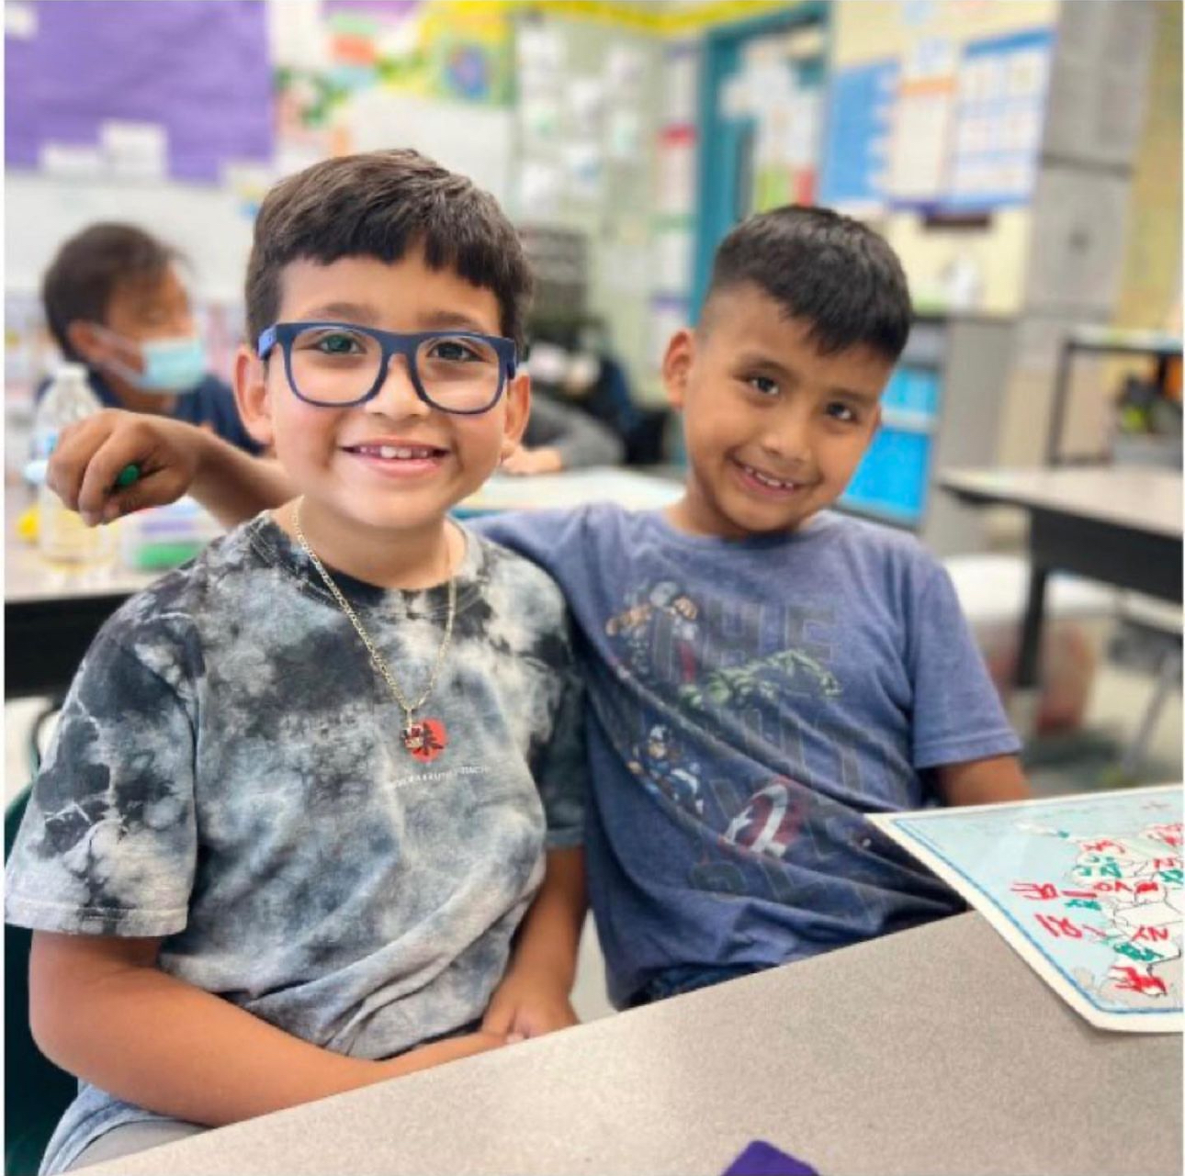
We have collectively launched successful K-12 summer school programs across the District. This is a commendable achievement that showcases our dedication to student growth and learning continuity. The Summer of Learning programs provide invaluable opportunities for students to catch up, get ahead, and explore new interests in an engaging environment.
- 108,554* unique student enrollment for all Summer of Learning Programs
(as of 6/28/24)
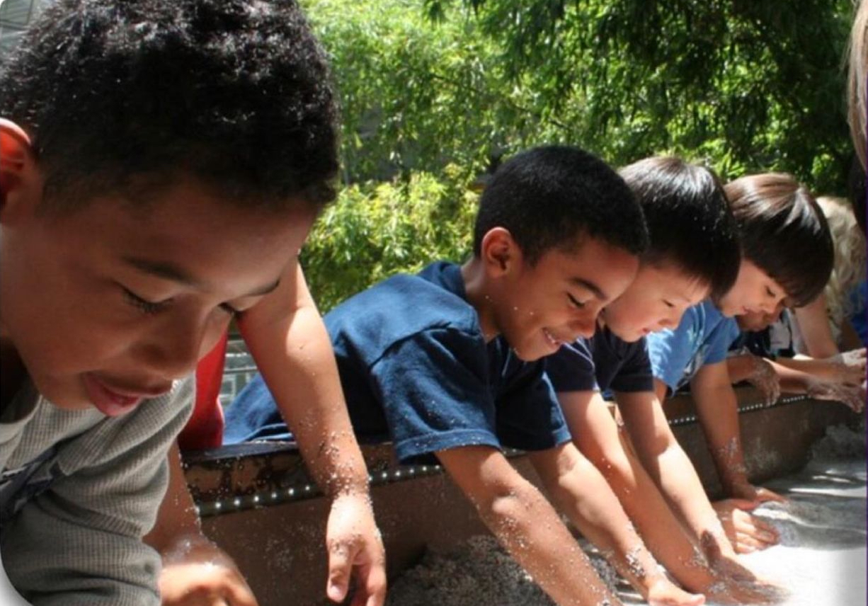
We deeply appreciate the hard work and commitment of our educators and staff in making these programs a reality, ensuring a brighter future for our students. Below our weekly highlights of our Summer of Learning programs.

SUMMER SCHOOL, UTK-8
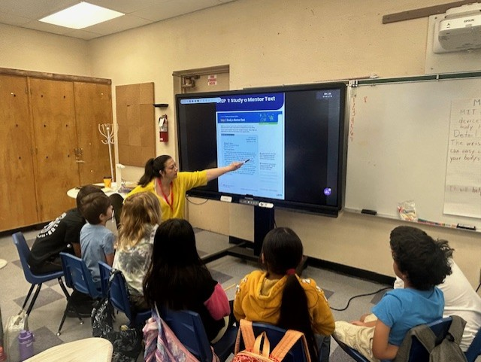
The UTK-8 Summer School program is offered in person and is designed to support core instruction, provide targeted academic intervention in a small group setting, as well as in-person enrichment activities in the Arts and Sciences. This week spotlights students receiving explicit writing instruction by analyzing mentor text at Pinewood ES.

- 32,079* unique student enrollment for UTK-8 Programs (as of 6/28/24)
- 12,300 Pre-Assessments completed district-wide for UTK-8 program students. (By Region: East: 3.8K, South 3.4K, North 3.2K, and West 1.9K)

- 1,027 classroom observations using the UTK-8 Classroom Observation Tool

For more information, please contact your Summer School Principal OR Ana Estevez, Director Beyond the Bell, at ana.estevez@lausd.net. Thank you!

HIGH SCHOOL SUMMER TERM
The High School Summer Term program offers credit recovery to students in grades 9-12. Students may enroll in two in-person courses taught by LAUSD secondary teachers and two virtual asynchronous Edgenuity courses. Students can retake a variety of core and elective courses to meet A-G graduation requirements and be Ready for the World! This week’s highlights include Crenshaw HS English 9A students writing argumentative essays and providing feedback to their peers and Sotomayor HS World History B students working with their teacher on a “Rise of Totalitarianism” essay and Geometry B students working with their teacher on IXL problems that use the Pythagorean theorem.
- 594 classroom observations as of 6/27/24 using the High School Classroom Observation Tool
- 31,264* unique student enrollment for High School Summer Term In person (as of 6/28/24)
- 19,656* unique student enrollment for High School Summer Term Virtual (as of 6/28/24)
For more information, please contact your Summer School HS Principal, counselor or Betsy Castillo, Director, Beyond the Bell at bac9874@lausd.net.

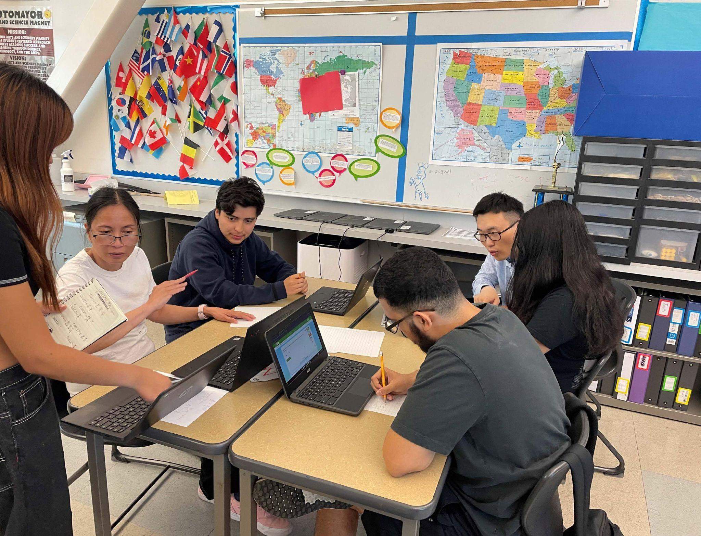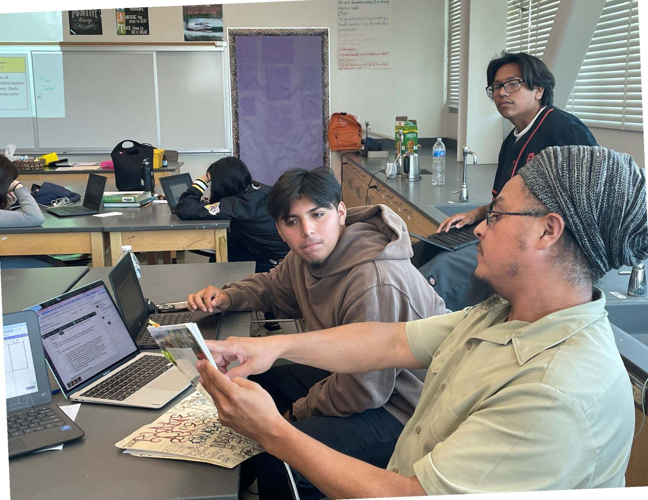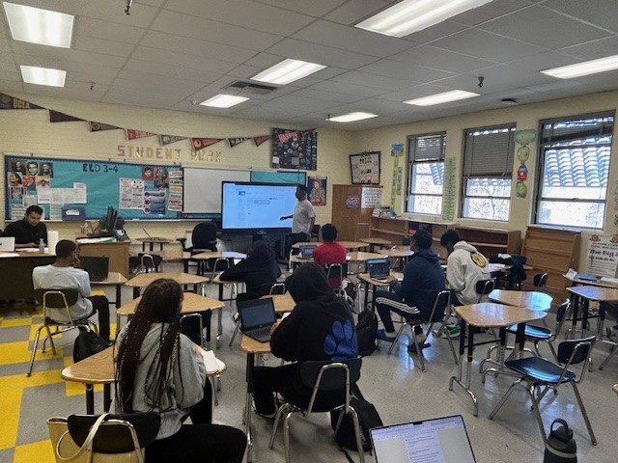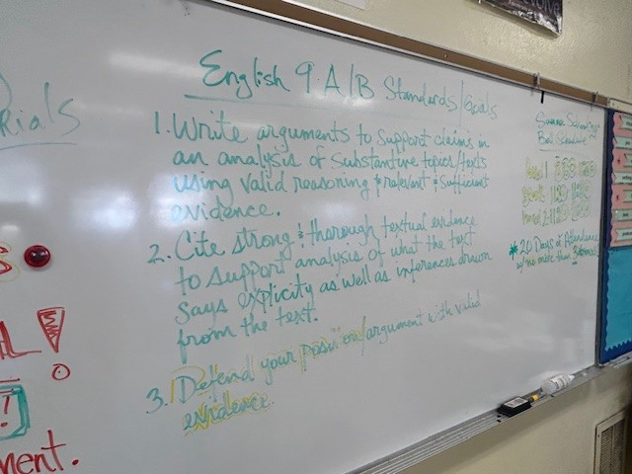

SUMMER CONTINUITY OF LEARNING FUN
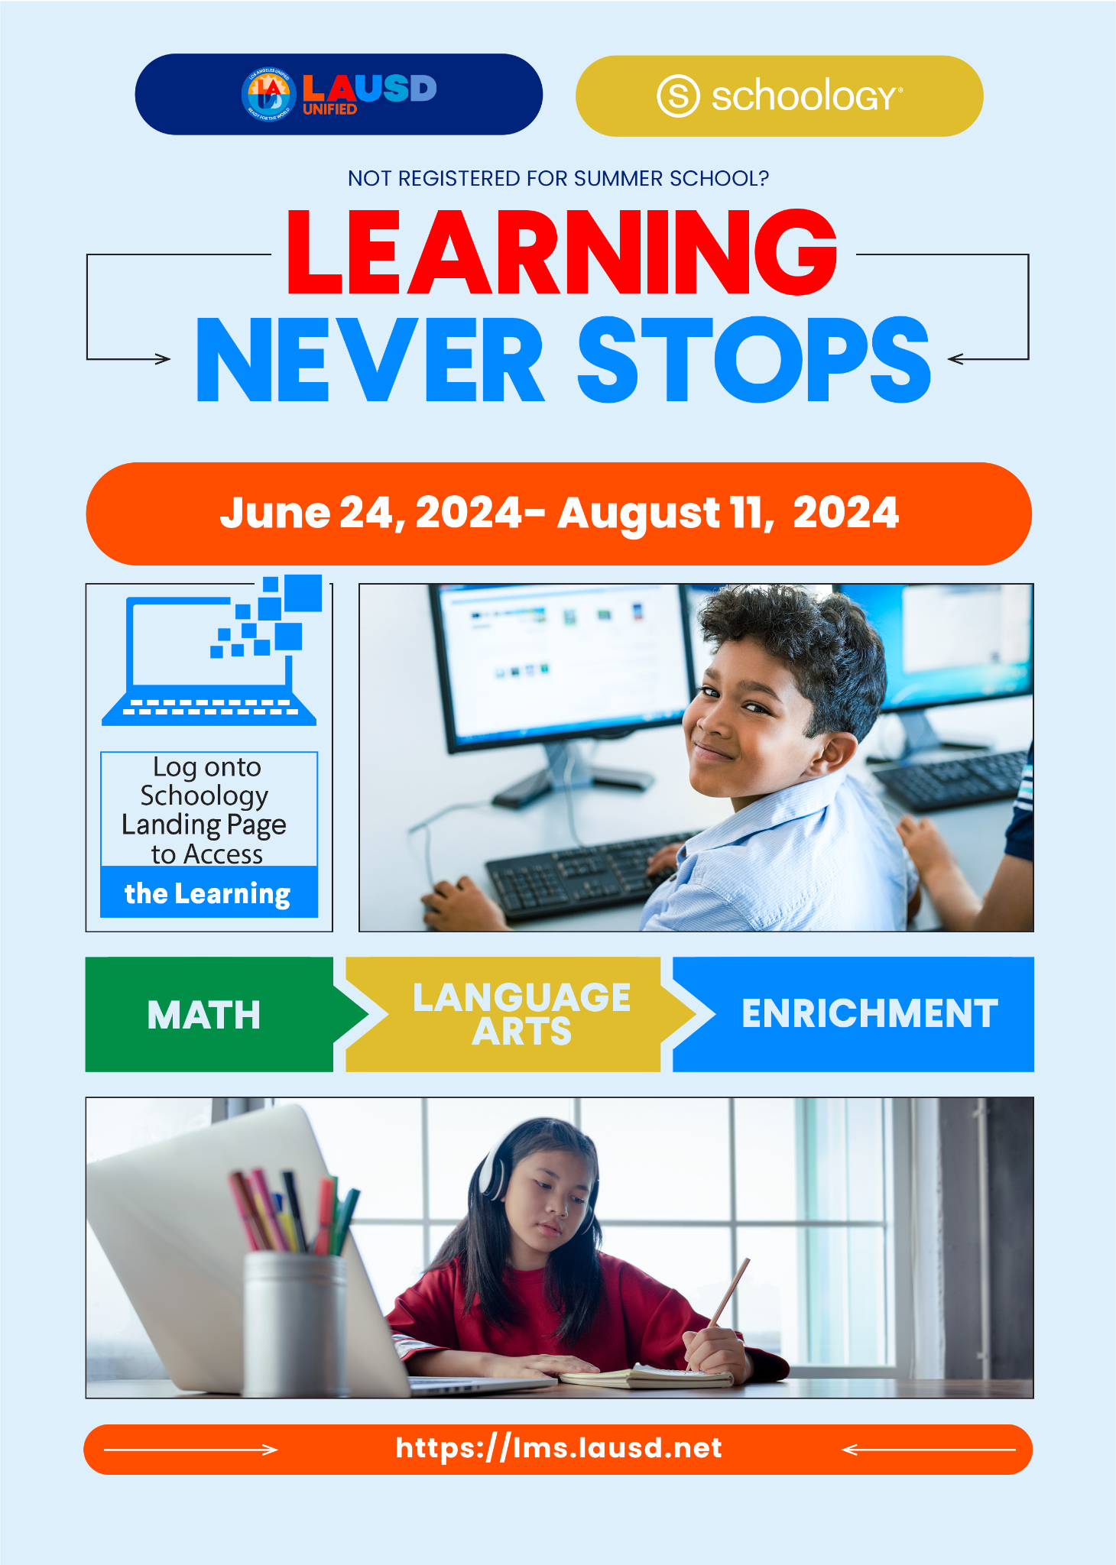
This week we launched the Summer Continuity of Learning lessons that offer engaging digital activities for all students during the summer break from June 24 - August 11, 2024.
- 70,042 unique users have accessed Continuity of Learning Lessons (as of 6/28/24)
- 📺 How to access learning activities: Video
For more information, please visit our Summer School website: Website or contact Tyra Henderson, Director of Elementary Instruction at tbrookin@lausd.net.

#LAUSD #SummerLearning #KeepLearning #EducationForAll

BRIDGE PROGRAMS
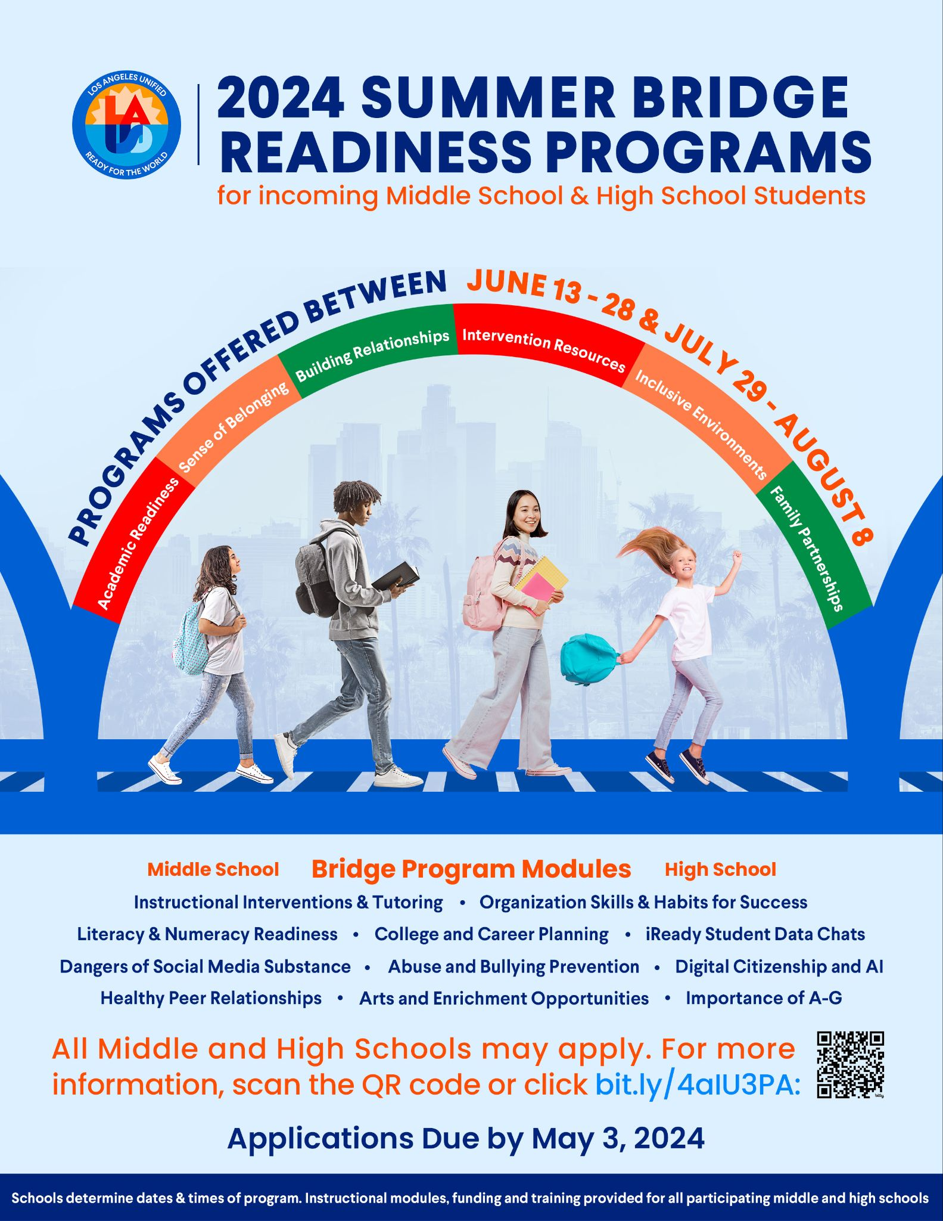
The Bridge Readiness Programs provide secondary schools the opportunity to offer incoming middle and high school students a comprehensive readiness experience. These programs aim to prepare students for academic success, nurture their identity, foster new relationships, engage in social-emotional learning, and ignite motivation for the upcoming academic year. Over 130 middle and high school programs, serving an estimated 10,500 students, provide 12 unique readiness instructional modules for teachers to engage students in relationship-building activities including: organization skills, digital citizenship in the age of AI, numeracy and literacy readiness including iReady data chats, healthy relationship and bullying awareness, an introduction to site resources and associated school staff, tutoring and intervention supports and a family engagement day designed to include families as partners in the success of their students in their new grade span.
- 1,421 unique student enrollment for June Bridge Programs (as of 6/28/24) (Most programs begin in July/August)
- Attendance for the week of June 24-28 (1,075 in June Bridge Readiness Programs)
For more information, please contact Dr. Justin Lauer, Director of Middle School Instruction, jxl9505@lausd.net
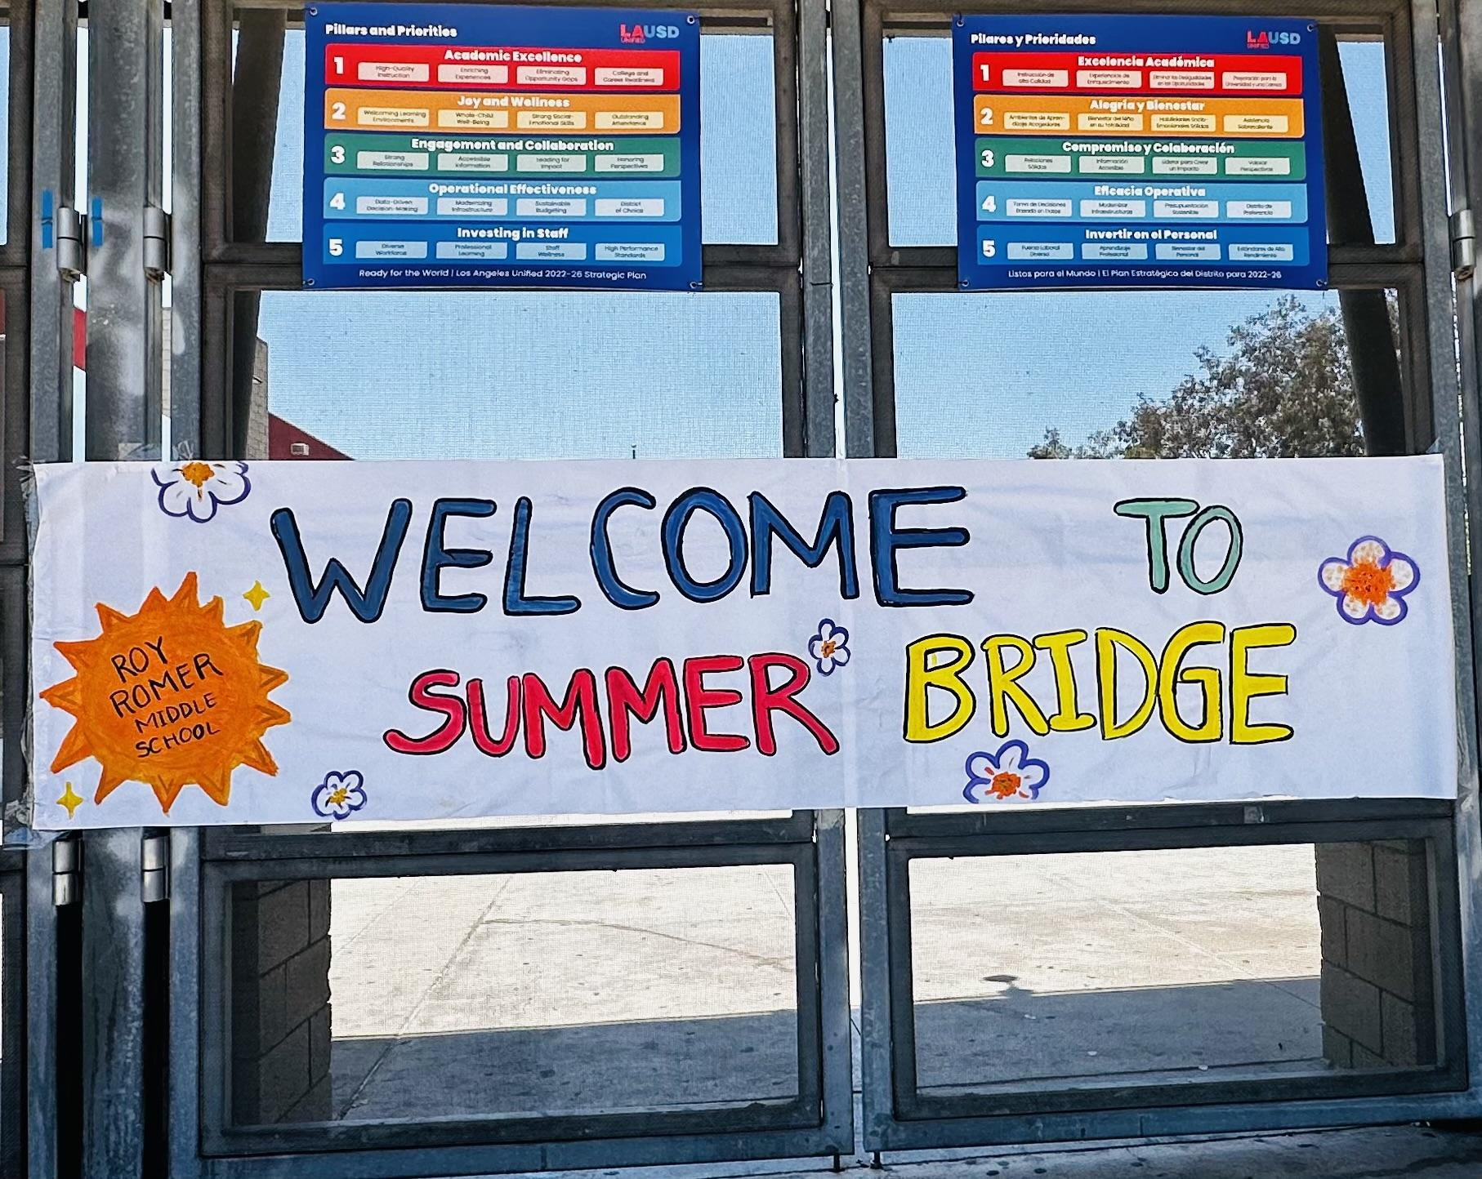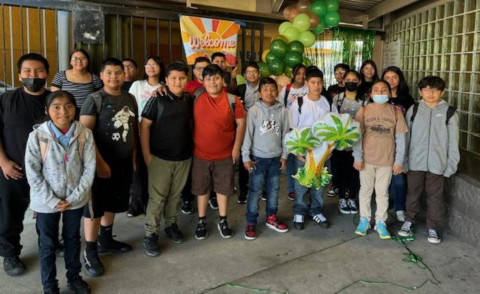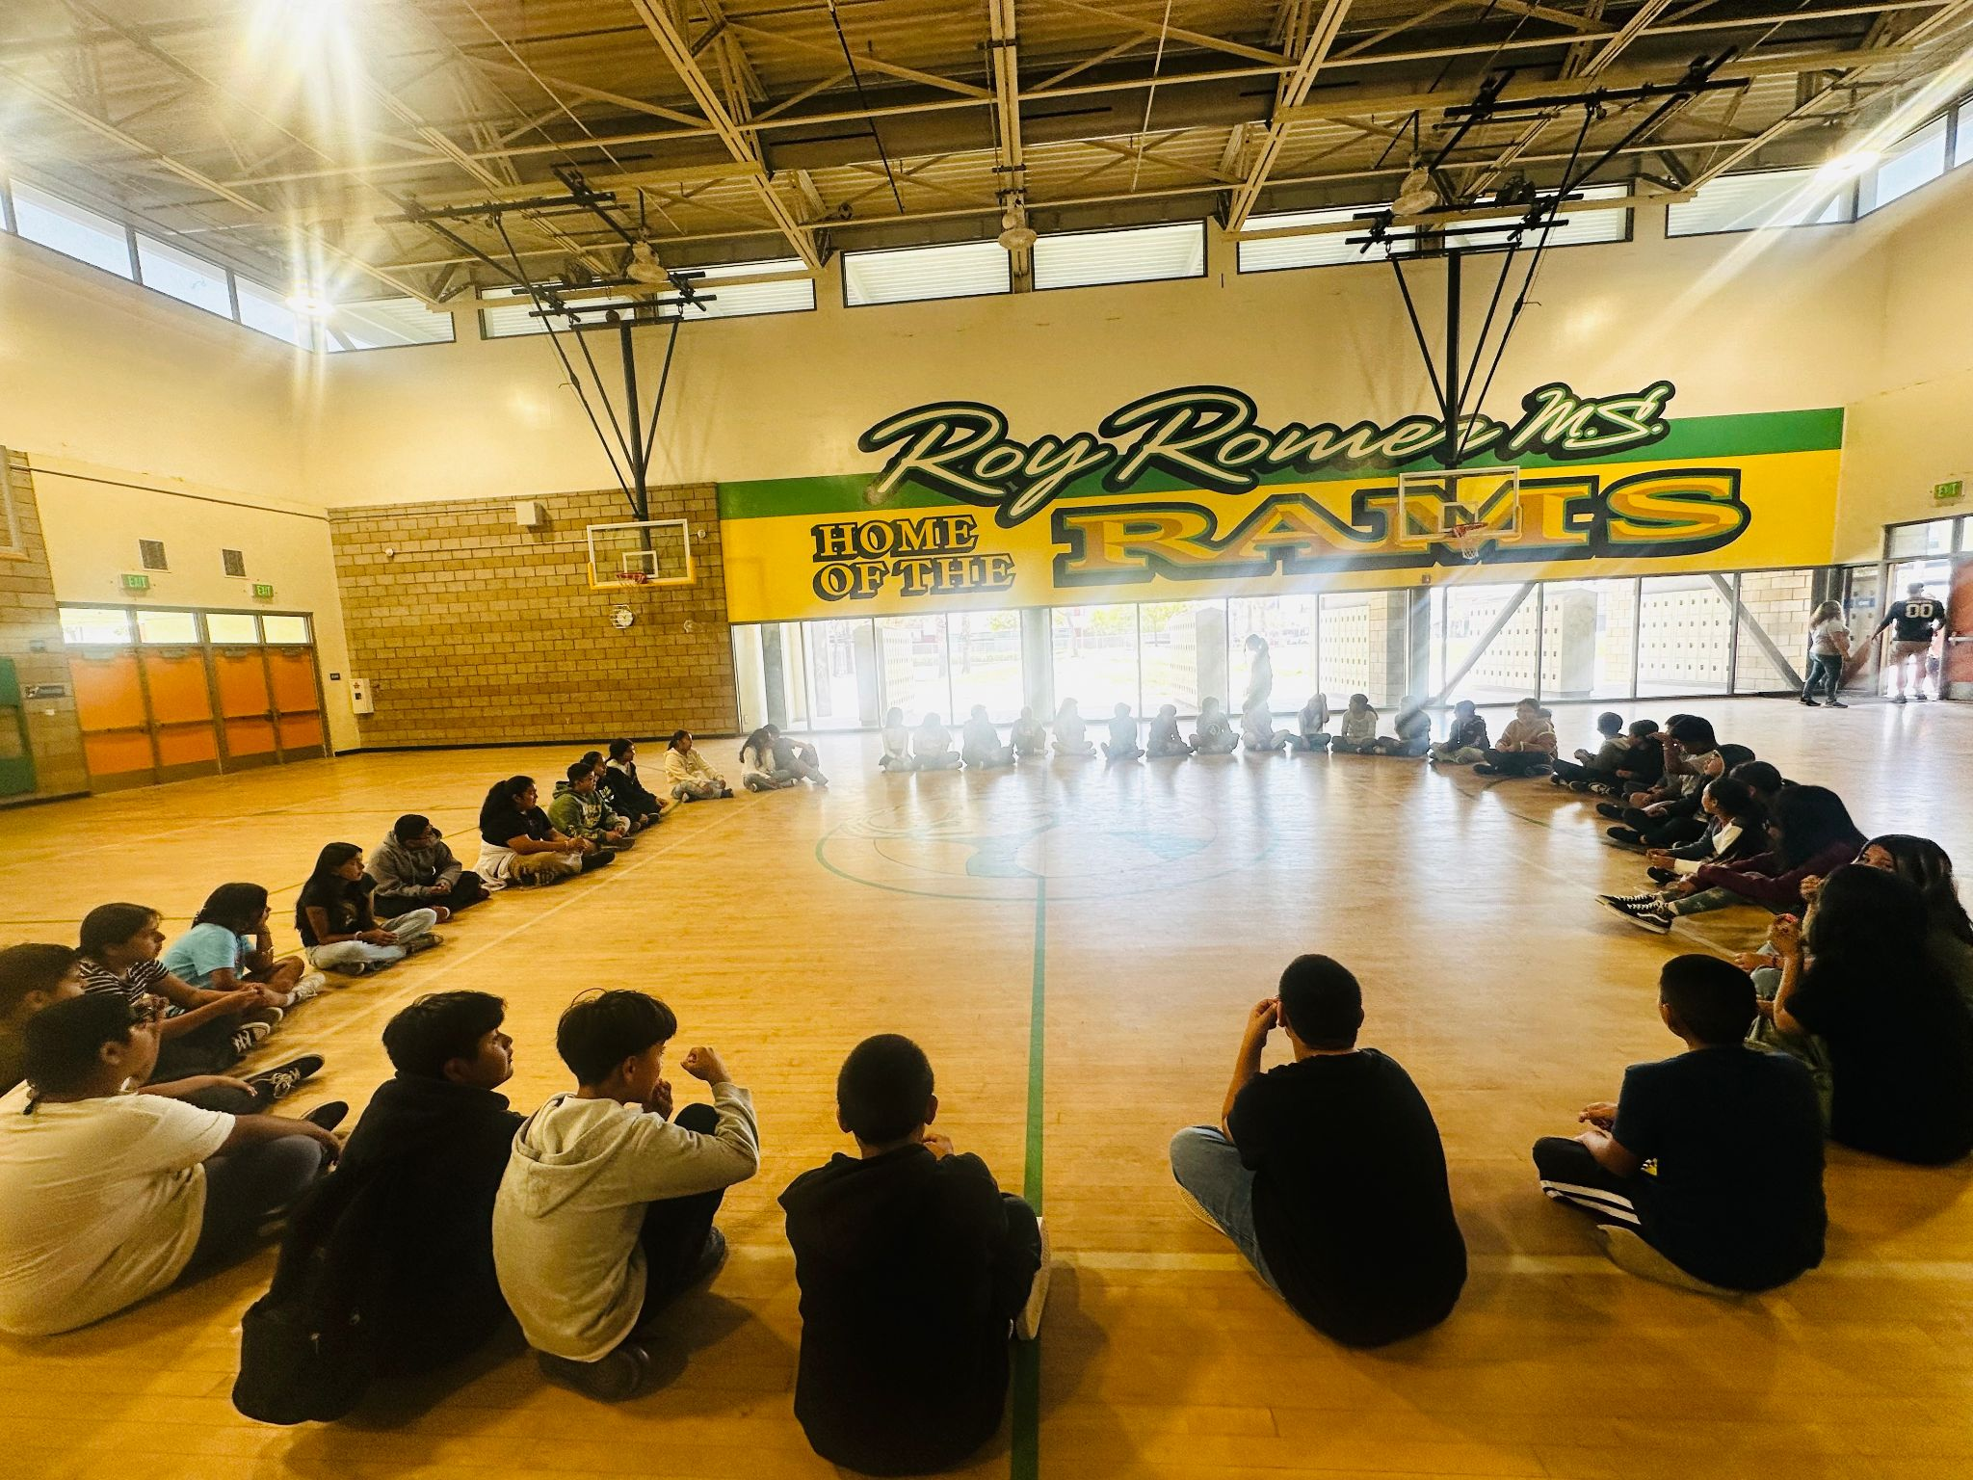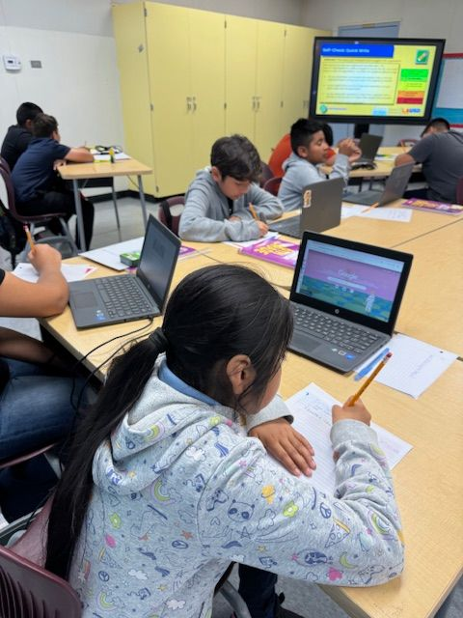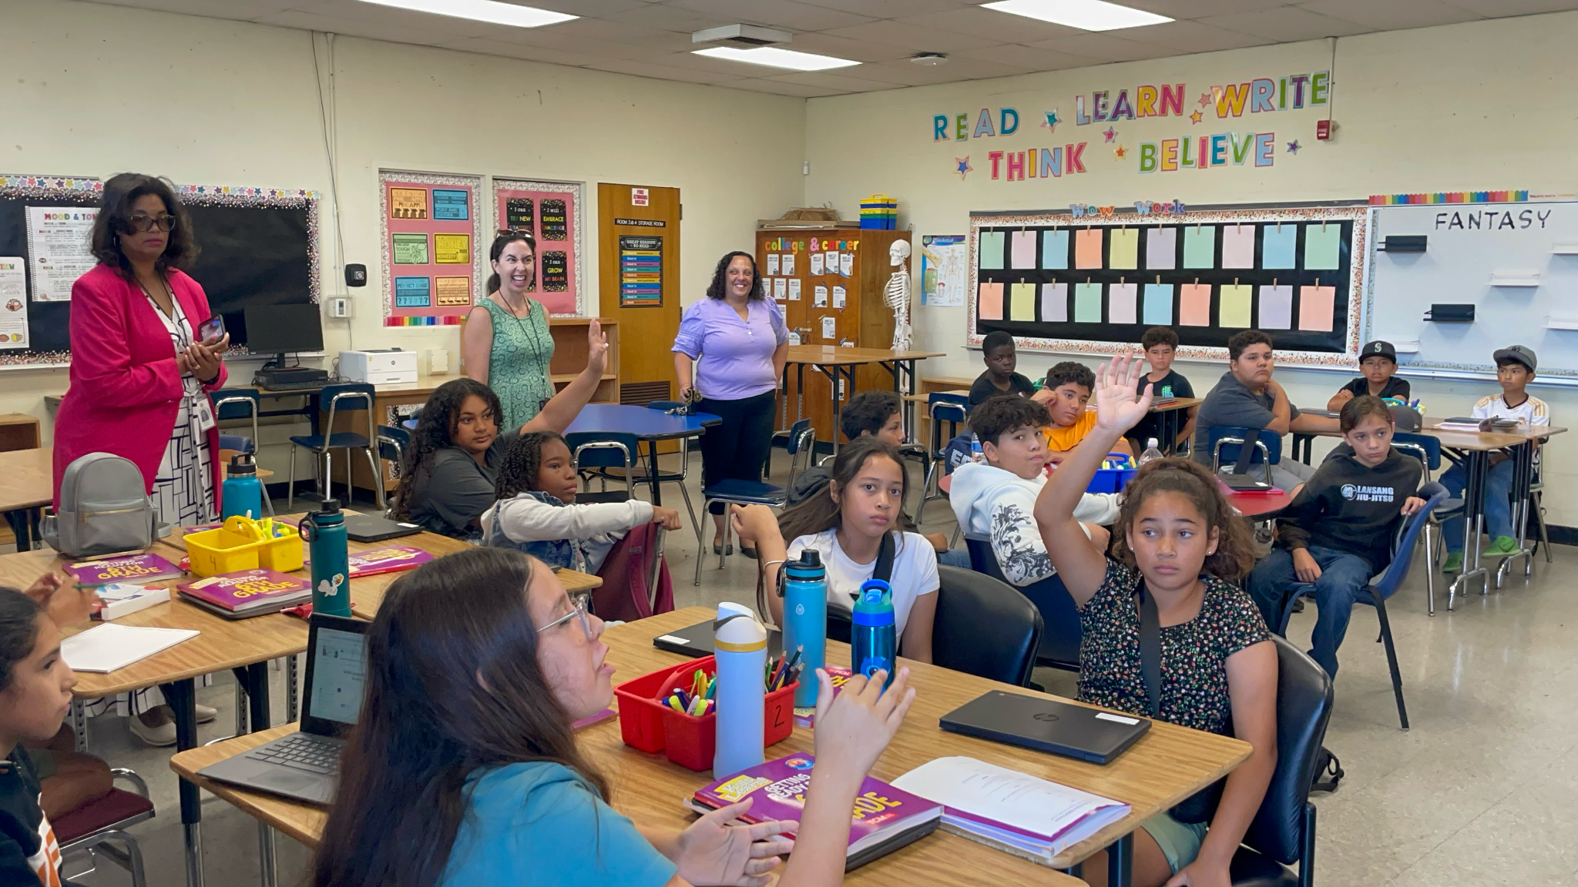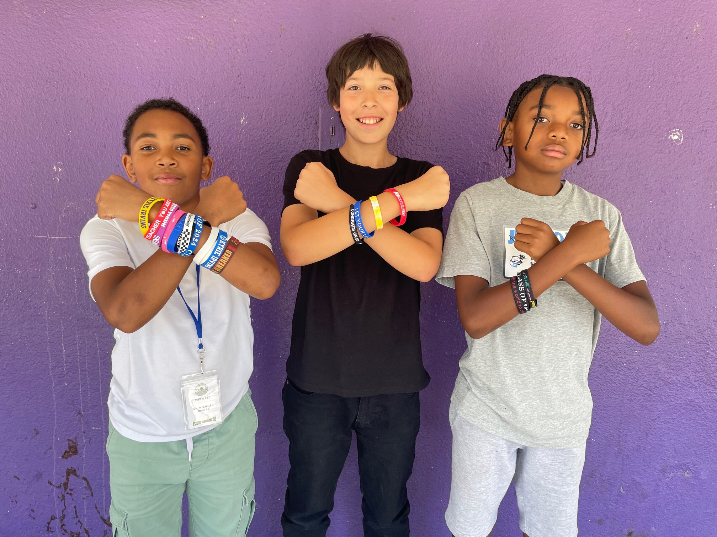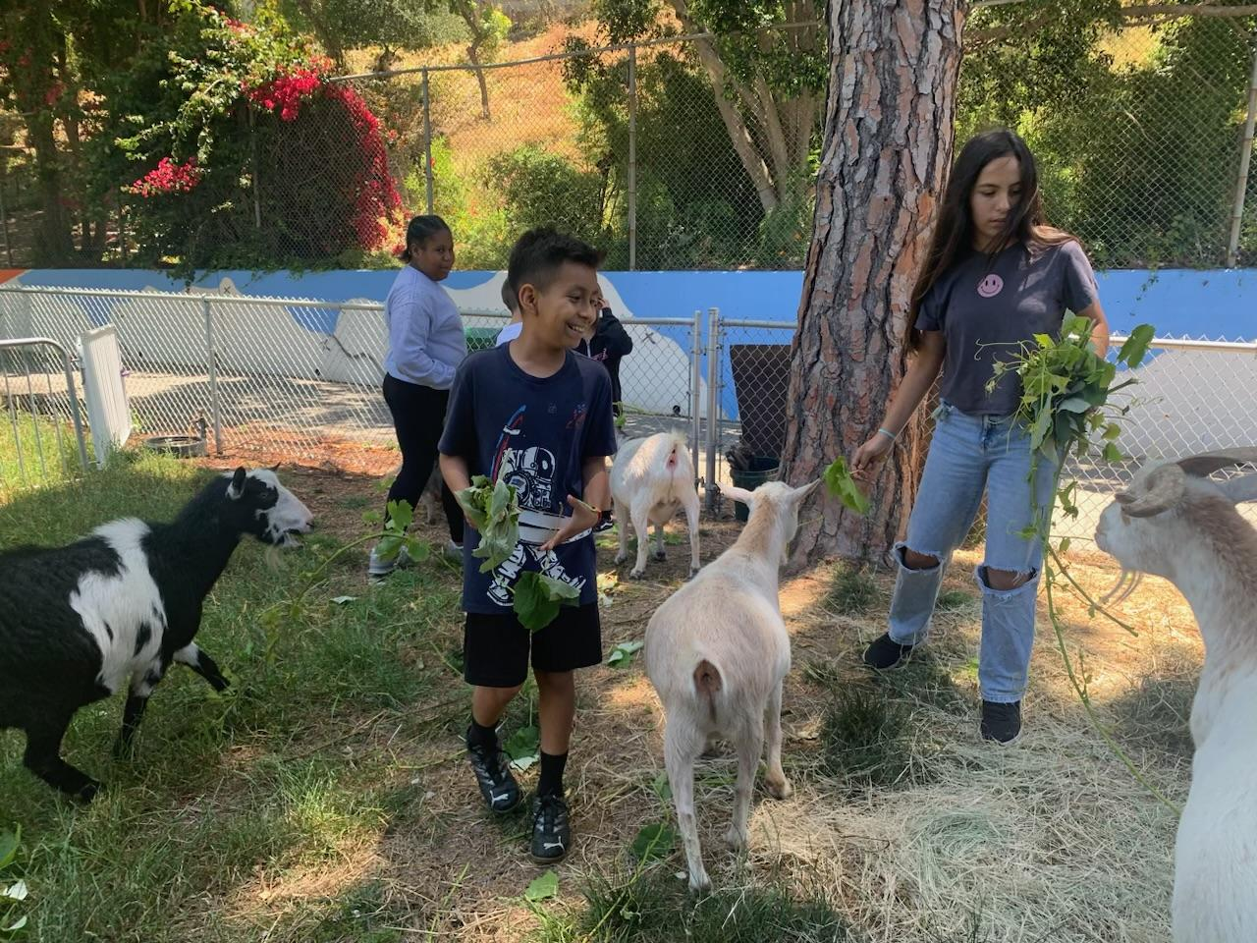
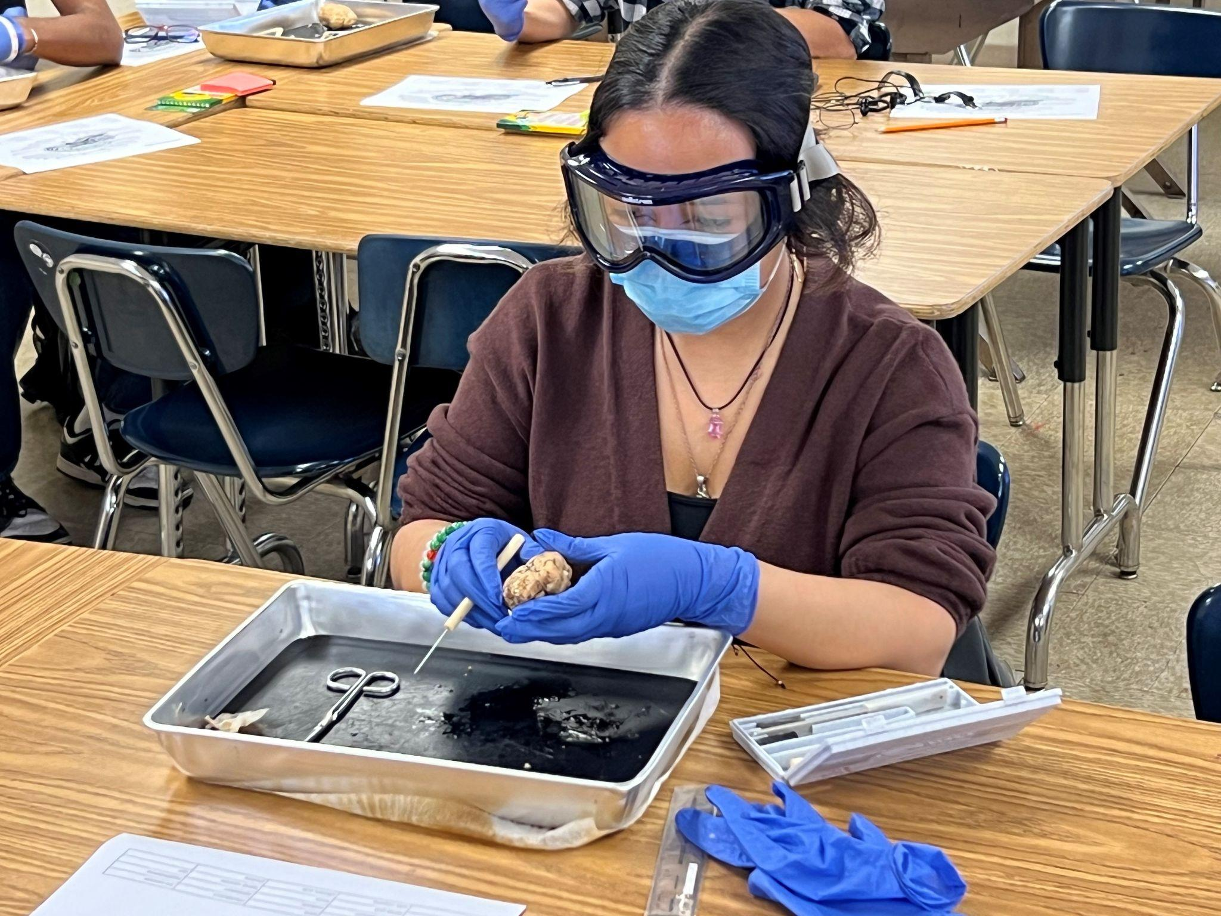
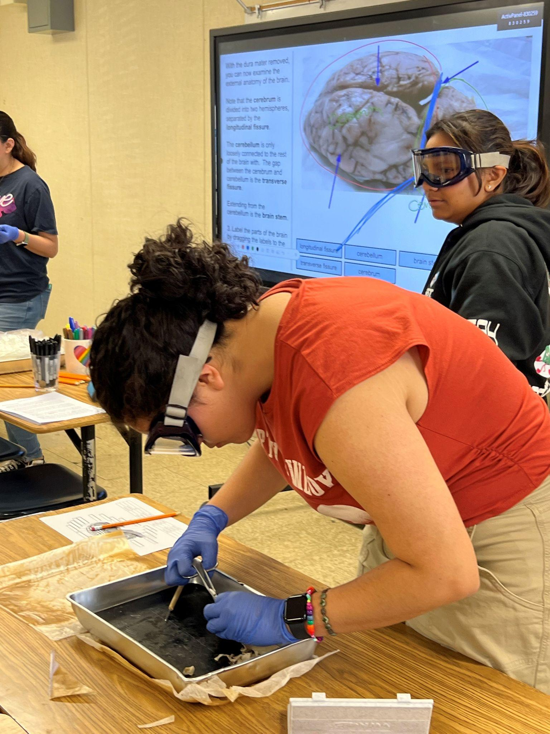
LINKED LEARNING SUMMER BRIDGE
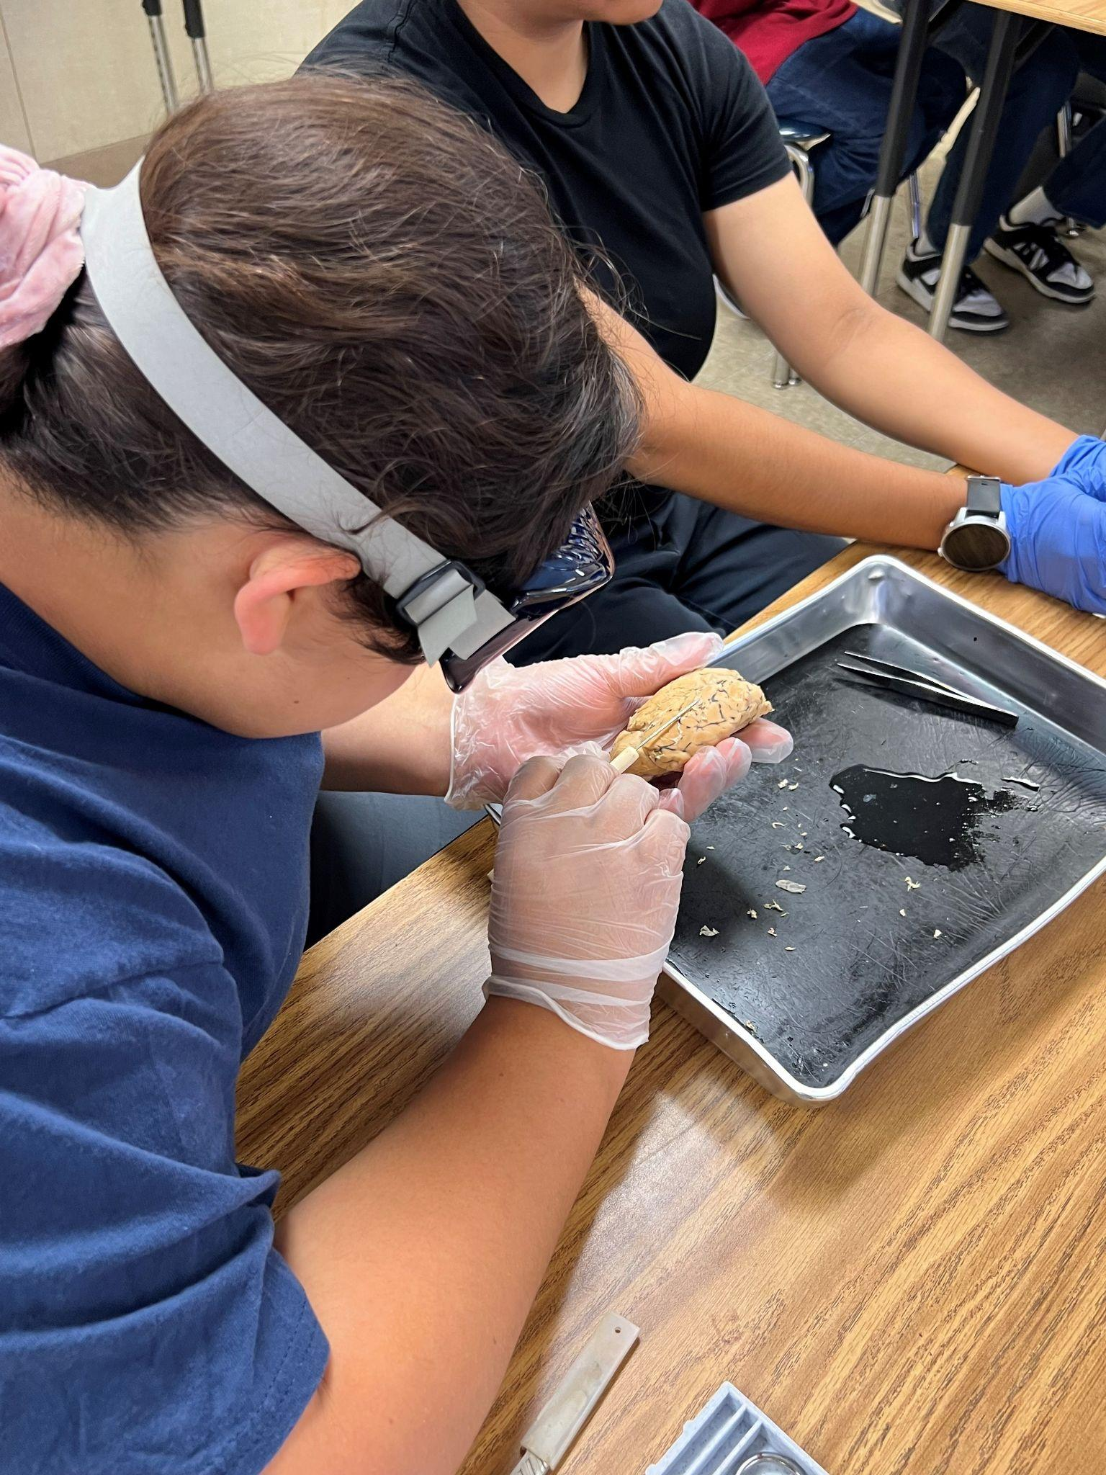
Linked Learning middle and high schools are welcoming their students by introducing them to their career pathways and project-based learning. Over 2200 students across the District participate in Linked Learning summer bridge programs allowing 40 Linked Learning pathways to get to know their new classmates, teachers, campus and provide an academic challenge before the school year starts. They are even supported by older students who have the role of mentors and are paid interns.
For more information, please contact Susan Canjurasusan.canjura@lausd.net

JO BOALER MATH CAMP
The Jo Boaler Math Camp is a unique opportunity where students experience interactive and visual math lessons designed by world-renowned and Stanford University Professor, Dr. Jo Boaler. Students are engaging in collaborative activities that are intentionally planned with actions and messages that help students develop a growth mindset.
- 100* unique student enrollment for Jo Boaler Summer Math Camp (as of 6/28/24)
For more information, please contact Chiae Byun-Kitayama at cbyun1@lausd.net.
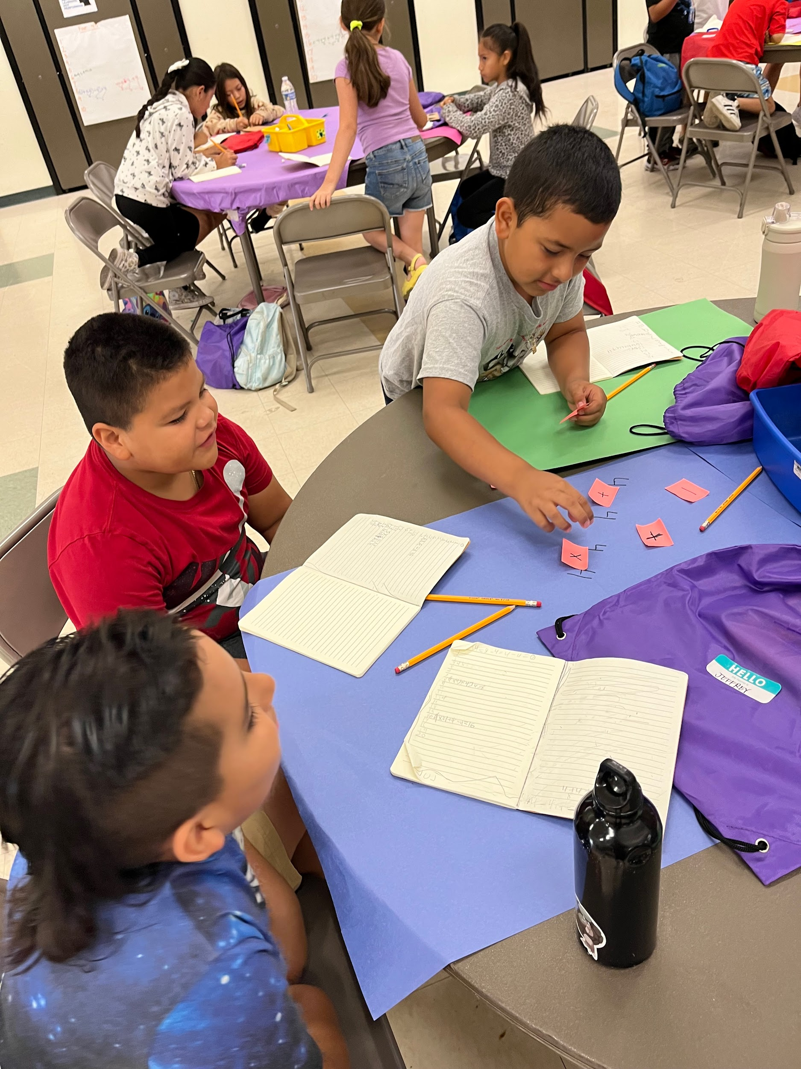
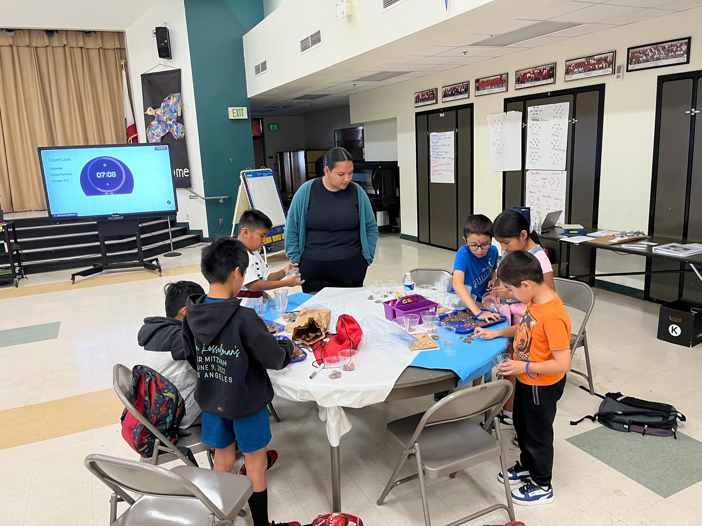
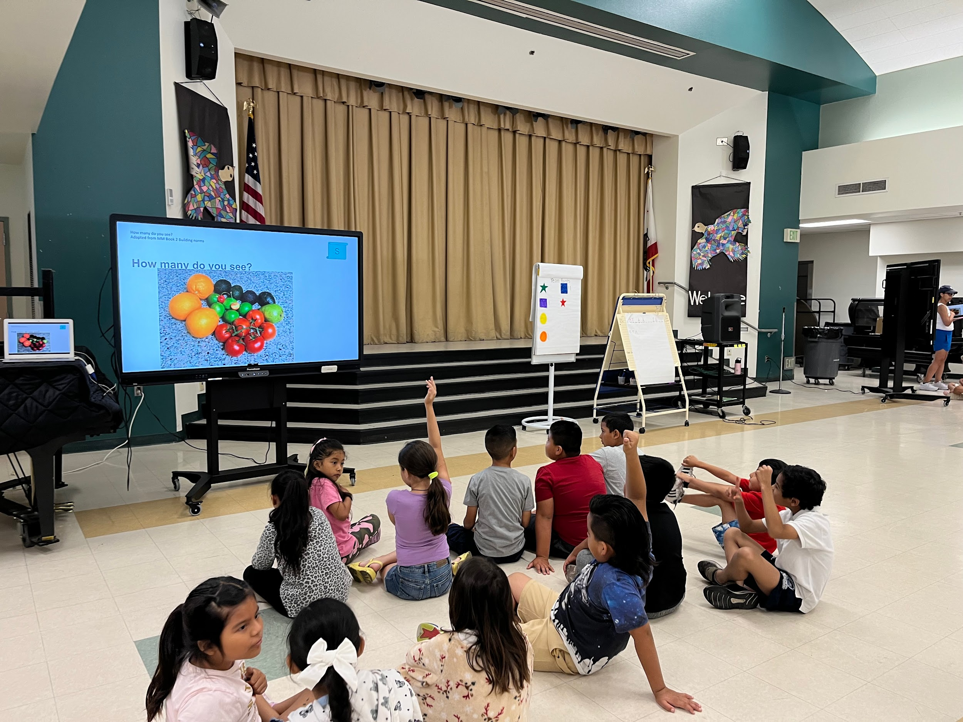
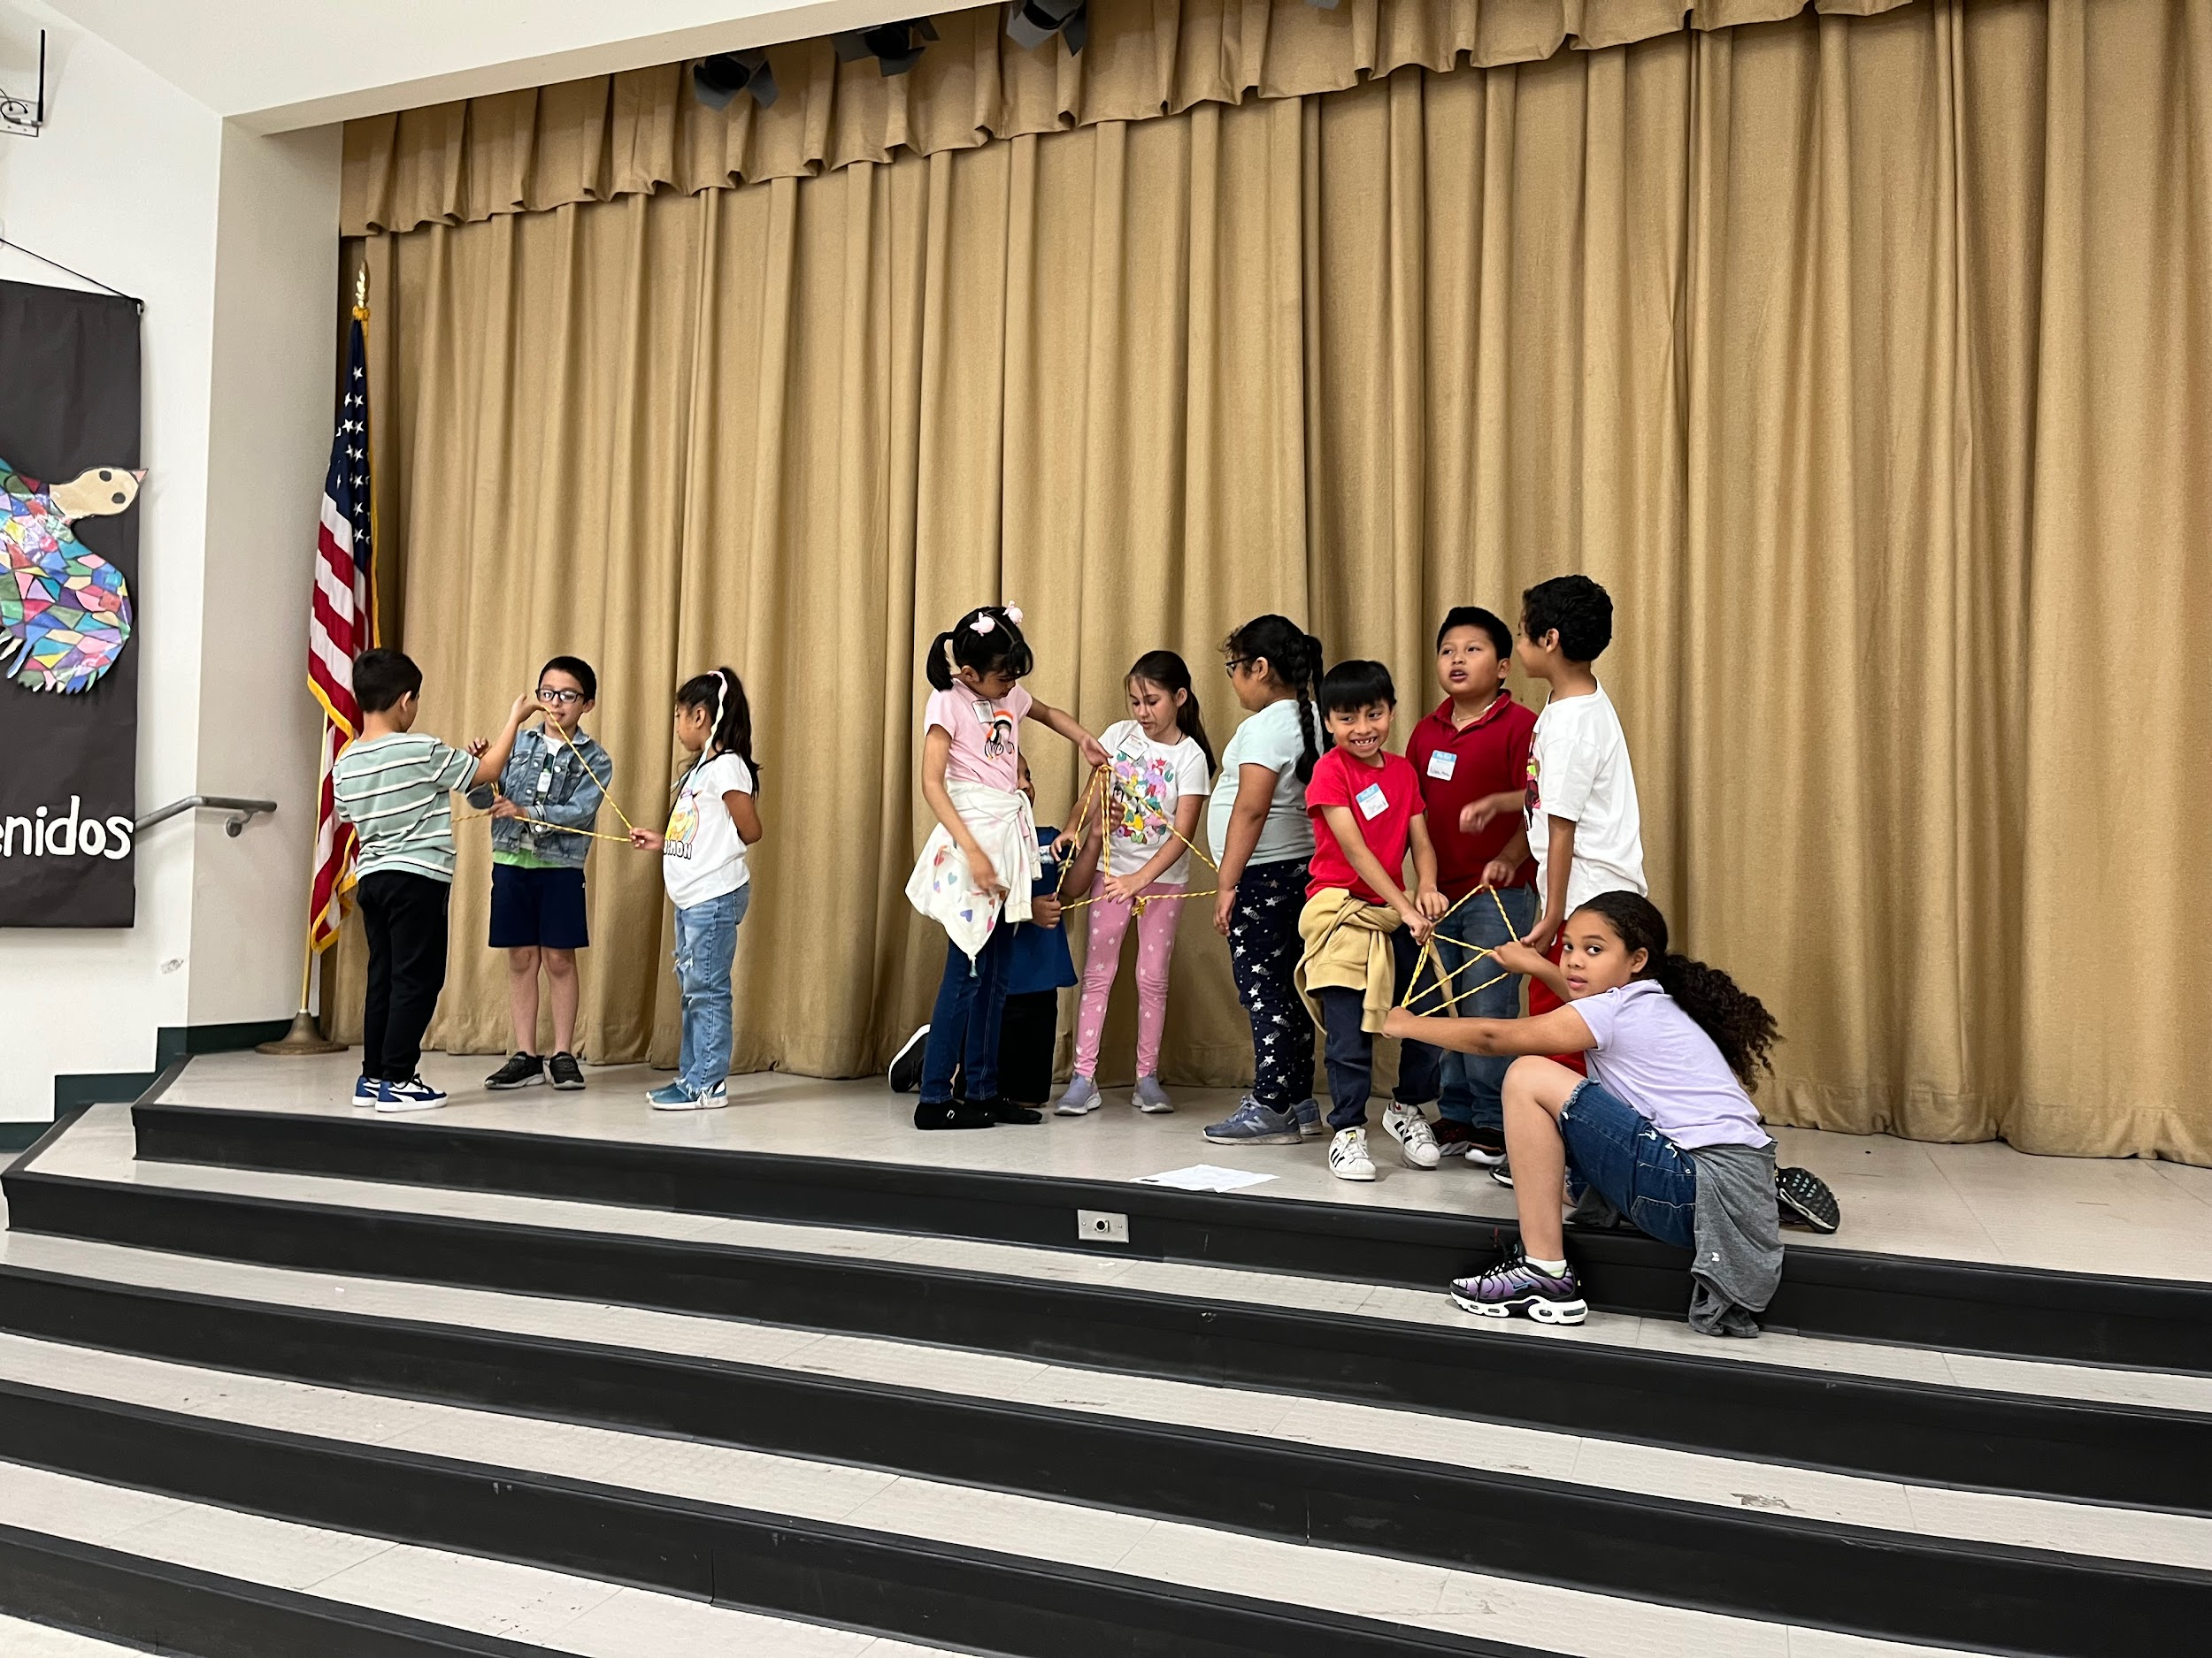

STEM CAMP @ THE SCIENCE CENTER
Students from Region East are experiencing the wonders of science firsthand at the LAUSD STEAM Camp at the California Science Center. They are diving into the fascinating world of biomimicry by designing and launching rockets based on sea animals, exploring how acids create vibrant colors on tie-dyed shirts, and discovering how to conduct electricity in various materials. This immersive experience brings science to life, sparking curiosity and creativity in every student.
- 145*unique student enrollment for the Region East STEM Camp (as of 6/28/24)
For more information, please contact Jaspreet Sandha at jaspreet.sandha@lausd.net.

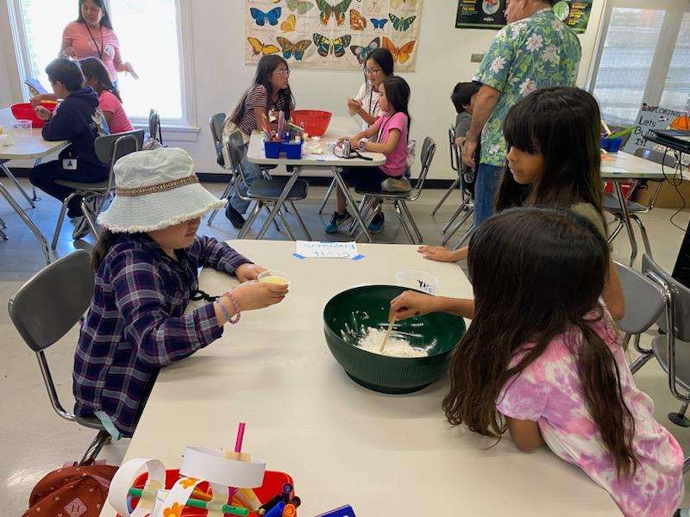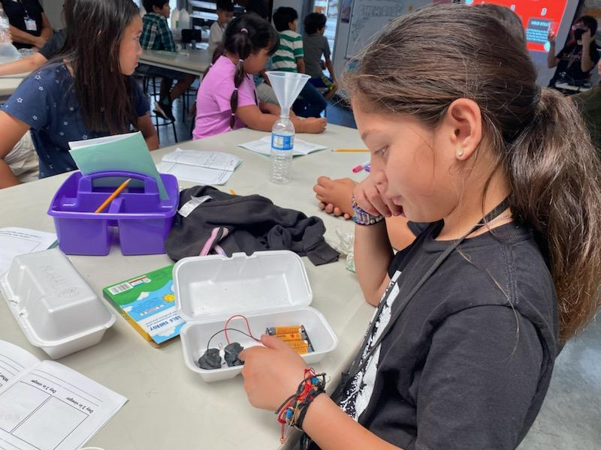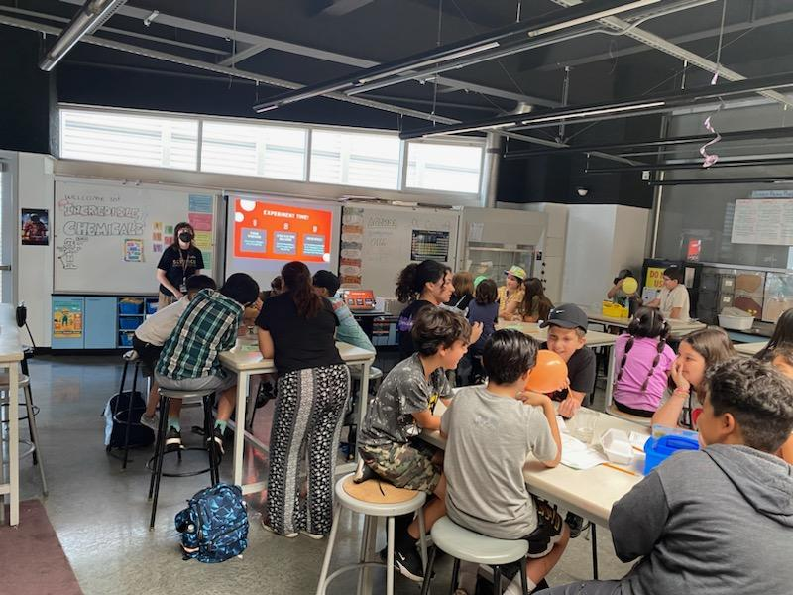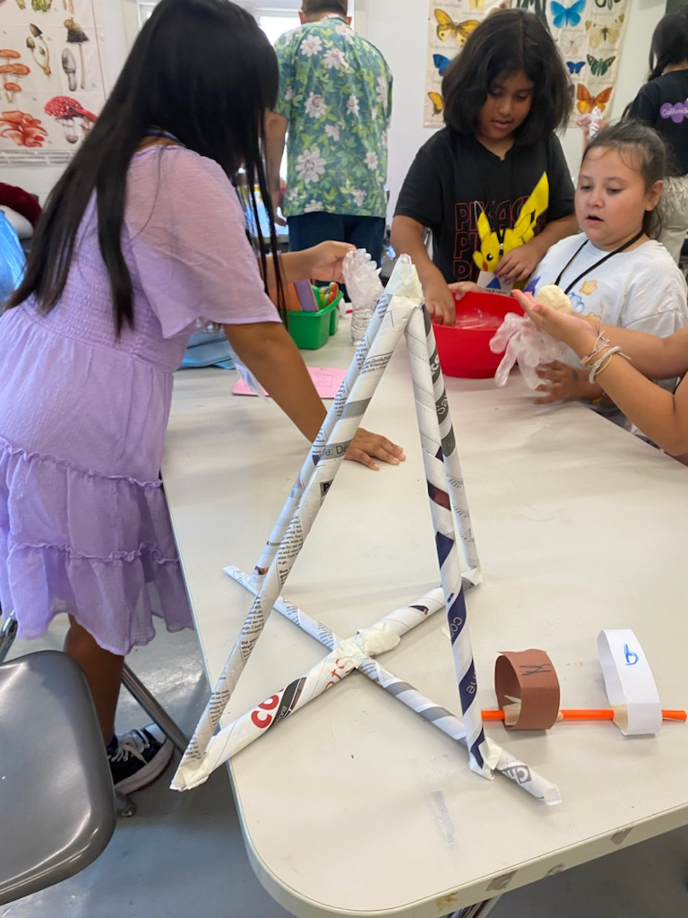

Extended School Year (ESY)
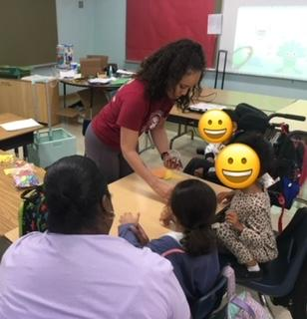
ESY has launched at 65 sites across the District. ESY is an IEP-determined service for students who require special education instruction or related services to prevent regression. Core ESY is using the same curriculum as ELOS this year, including STEAM kits, PE and Art enrichment materials.
Below are highlights of students receiving OT services at 99th Street Elementary and students in their ESY class at Darby Elementary.

- 11,408*unique student enrollment for ESY (as of 6/28/24)
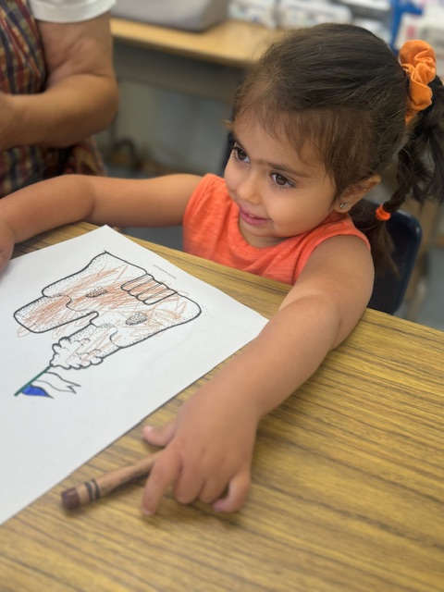
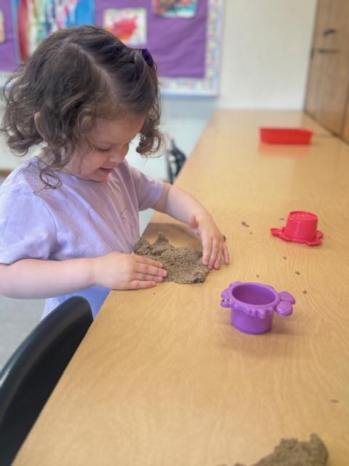
- Attendance = 7,841 as of 06/28/2024

For more information, please contact the Division of Special Education, at esy@lausd.net or (213) 241-6701. Thank you!

BEYOND THE BELL PROGRAMS

EXPANDED LEARNING PROGRAM
Beyond the Bell provides expanded learning programs for students in grades TK-12 at selected school sites for summer enrichment opportunities that provide academic engagement, physical activities, creative activities, and social-emotional learning.
- Attendance/Students Served - 21,375
Middle school dance program offers students summer learning opportunities in the creative arts. Students learn how to perform a “bridge” dance move. | Summer of Joy elementary field trip at the EXPO Center, hosted by Science of Sport through a Beyond the Bell partnership with GPSN. |  | Students engaged in learning about the history of Disney, animation, career paths, and story attributes like character and setting.

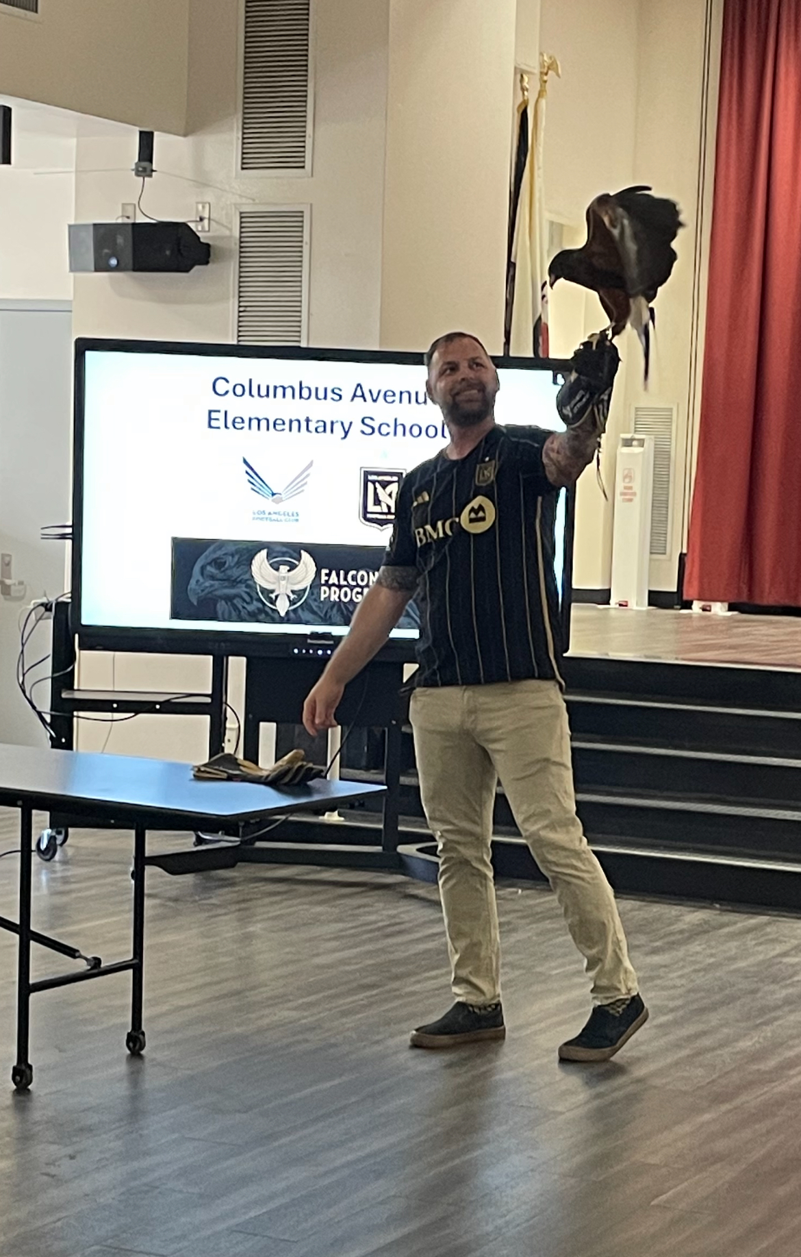
OUTDOOR EDUCATION CAMPS
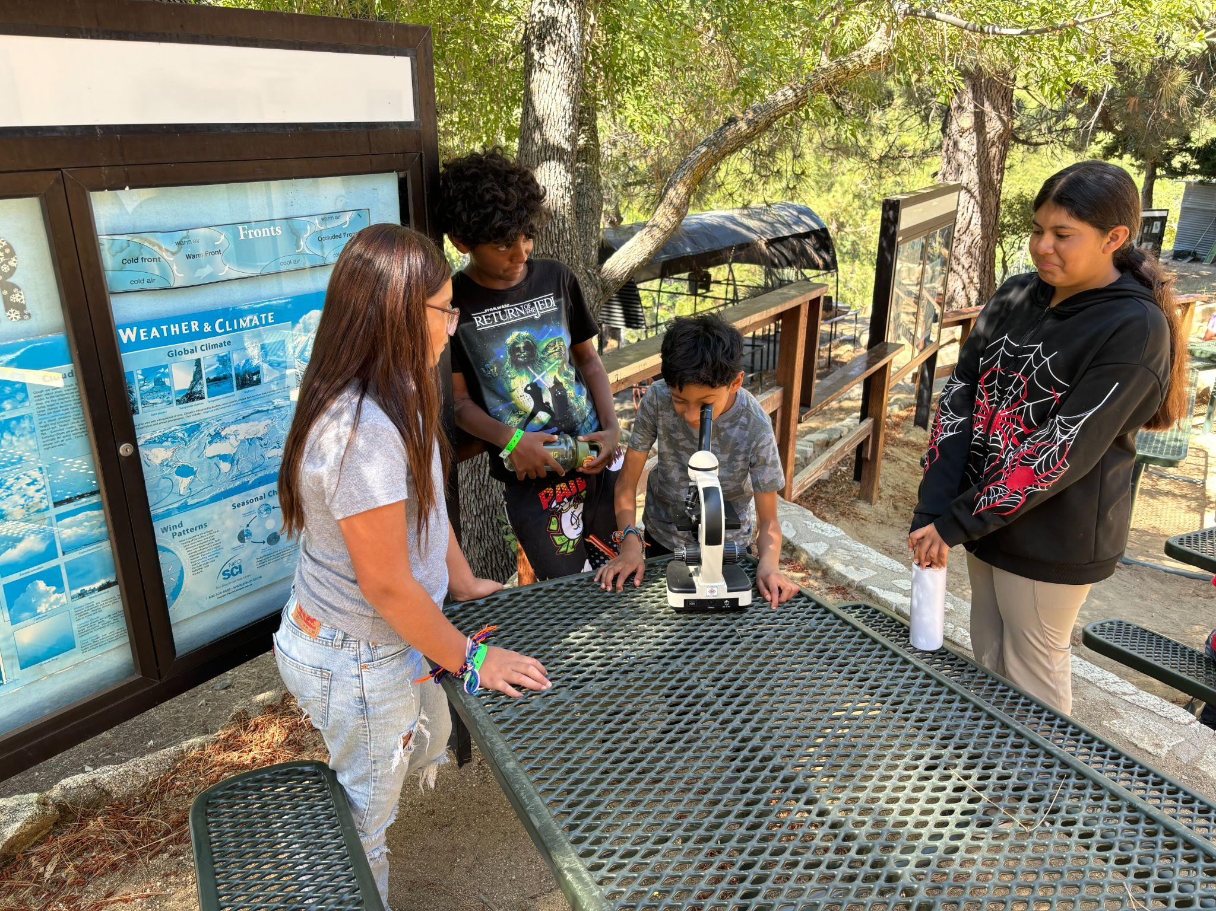
Students enjoy a visit from our partner Los Angeles Football Club Falcon program at Columbus Elementary. Students participating in a science activity at Camp Skyhook Clear Creek.
- Attendance: 1,704 students

NEWCOMER PROGRAM
The International Newcomer Enrichment Summer Program is open to high school students in grades 9th-12th, born outside of the U.S. and who have been enrolled in U.S. schools from 0 to 36 months. Students can receive up to ten elective credits towards A-G. In this course, students will receive academic language development support, wrap around services, and an enrichment field trip to The Getty Museum.

The first week of instruction integrated Art with English language development in whole group and small group settings. International Newcomer Students actively listened to, read about, and engaged in academic discussions with their peers about the life and storytelling artwork of Carmen Lomas Garza. Using her artwork as inspiration, students created their own construction paper collages about two childhood memories and shared an oral paragraph about a childhood memory with multiple classmates to practice their English language skills.

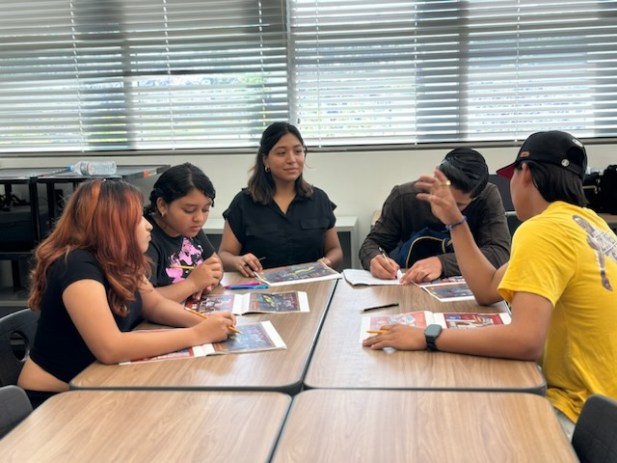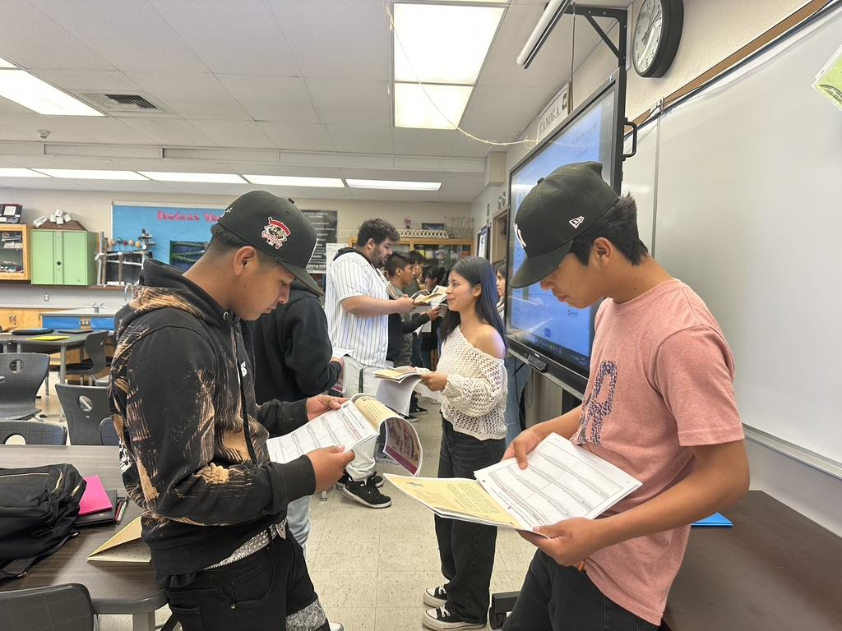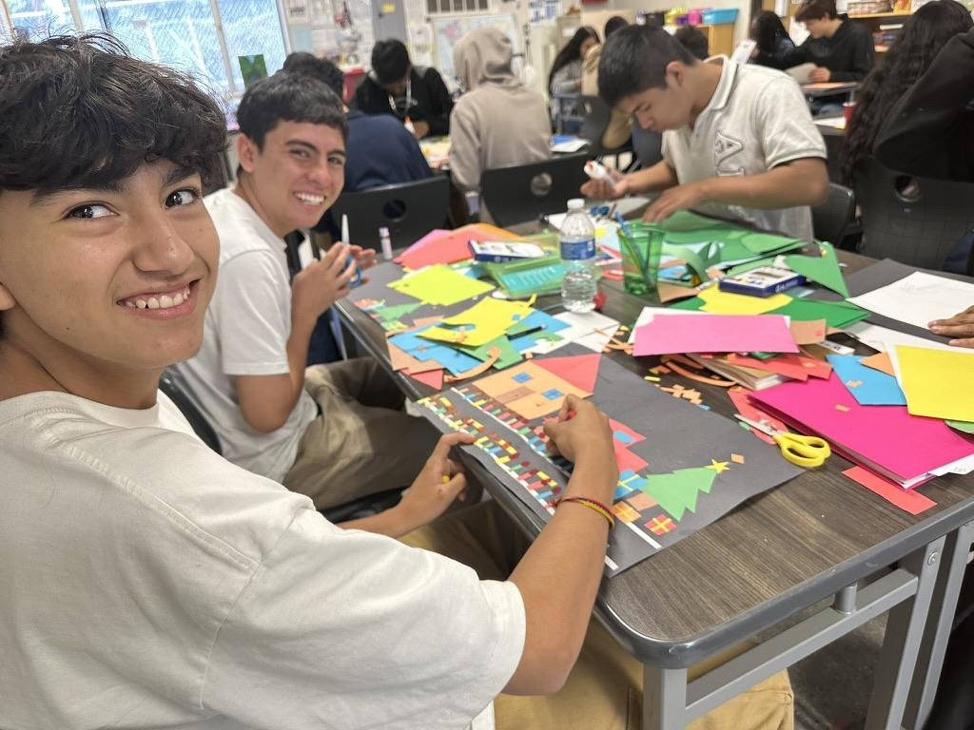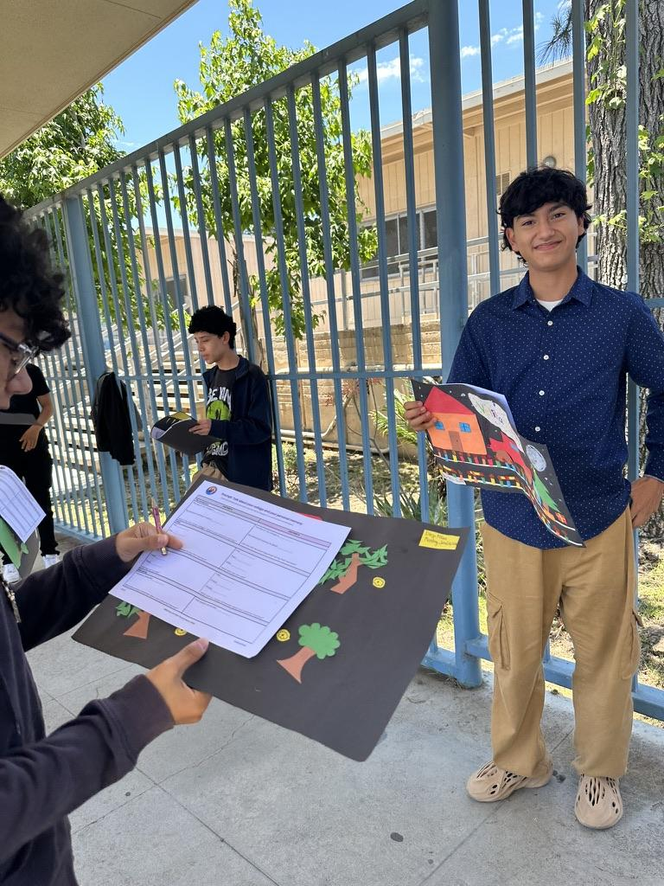
- 1,395* unique student enrollment for Newcomer Program (as of 6/28/24)
For more information, please contact Bernie Carrasco at @bcarrasc@lausd.net.

MIGRANT EDUCATION
The Migrant Education Summer Program offers student enrichment and academic programs, as well as family workshops. Below are the exciting programs available.
- 116* unique student enrollment for Migrant Education In Person (as of 6/28/24)
- 20* unique student enrollment for Migrant Education Online (as of 6/28/24)
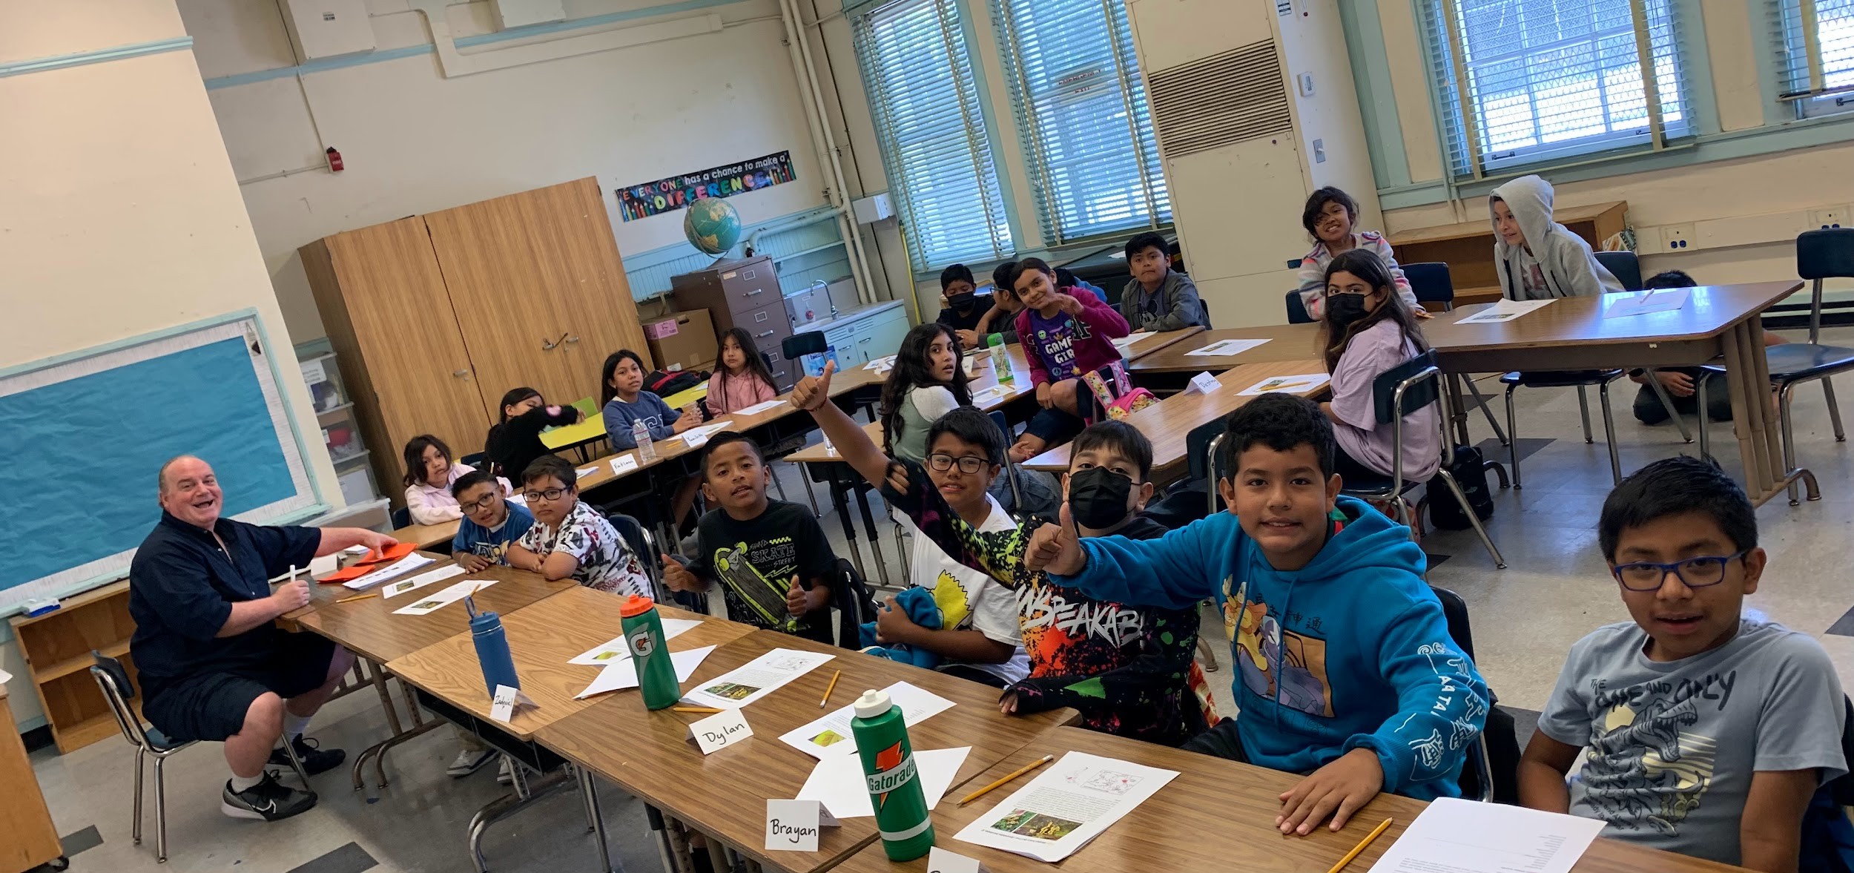
For more information, please contact victor.gonzalez@lausd.net or follow us Instagram and/or Facebook.

Partnership with the LA Zoo: Our classes spend two days of the week exploring the Zoo making observations, creating questions and discussing answers. Each class has one particular focus animal which they research and prepare presentations about. Presentations are given to all parents and the community on the last day along with numerous art works they create for the theme. These field trips are in many ways life changing experiences for them as many migrant students have not had many opportunities to visit all of the city’s resources and institutions.
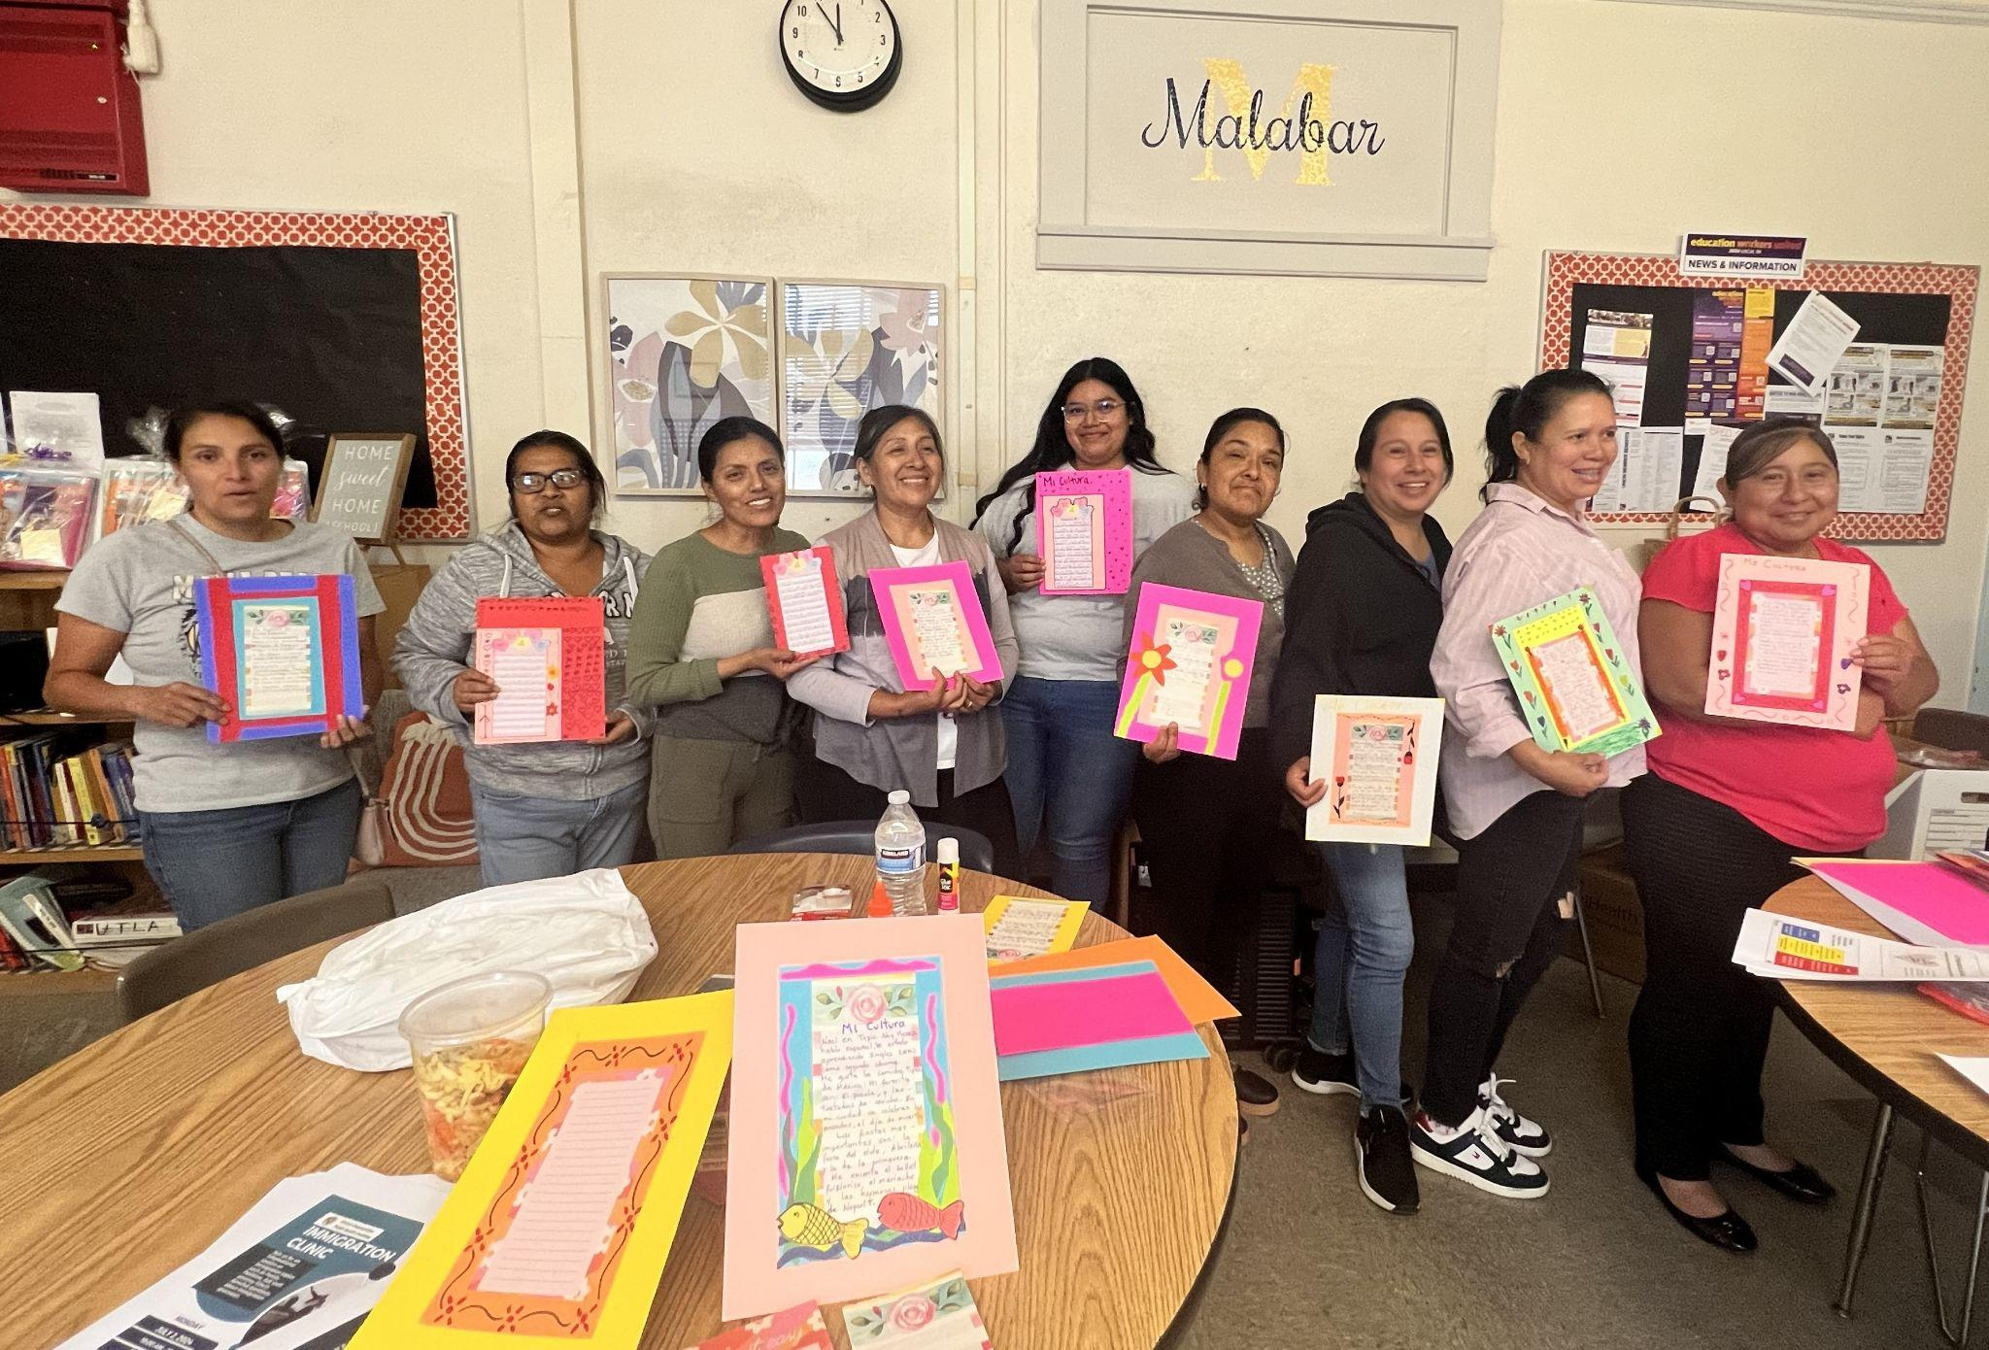
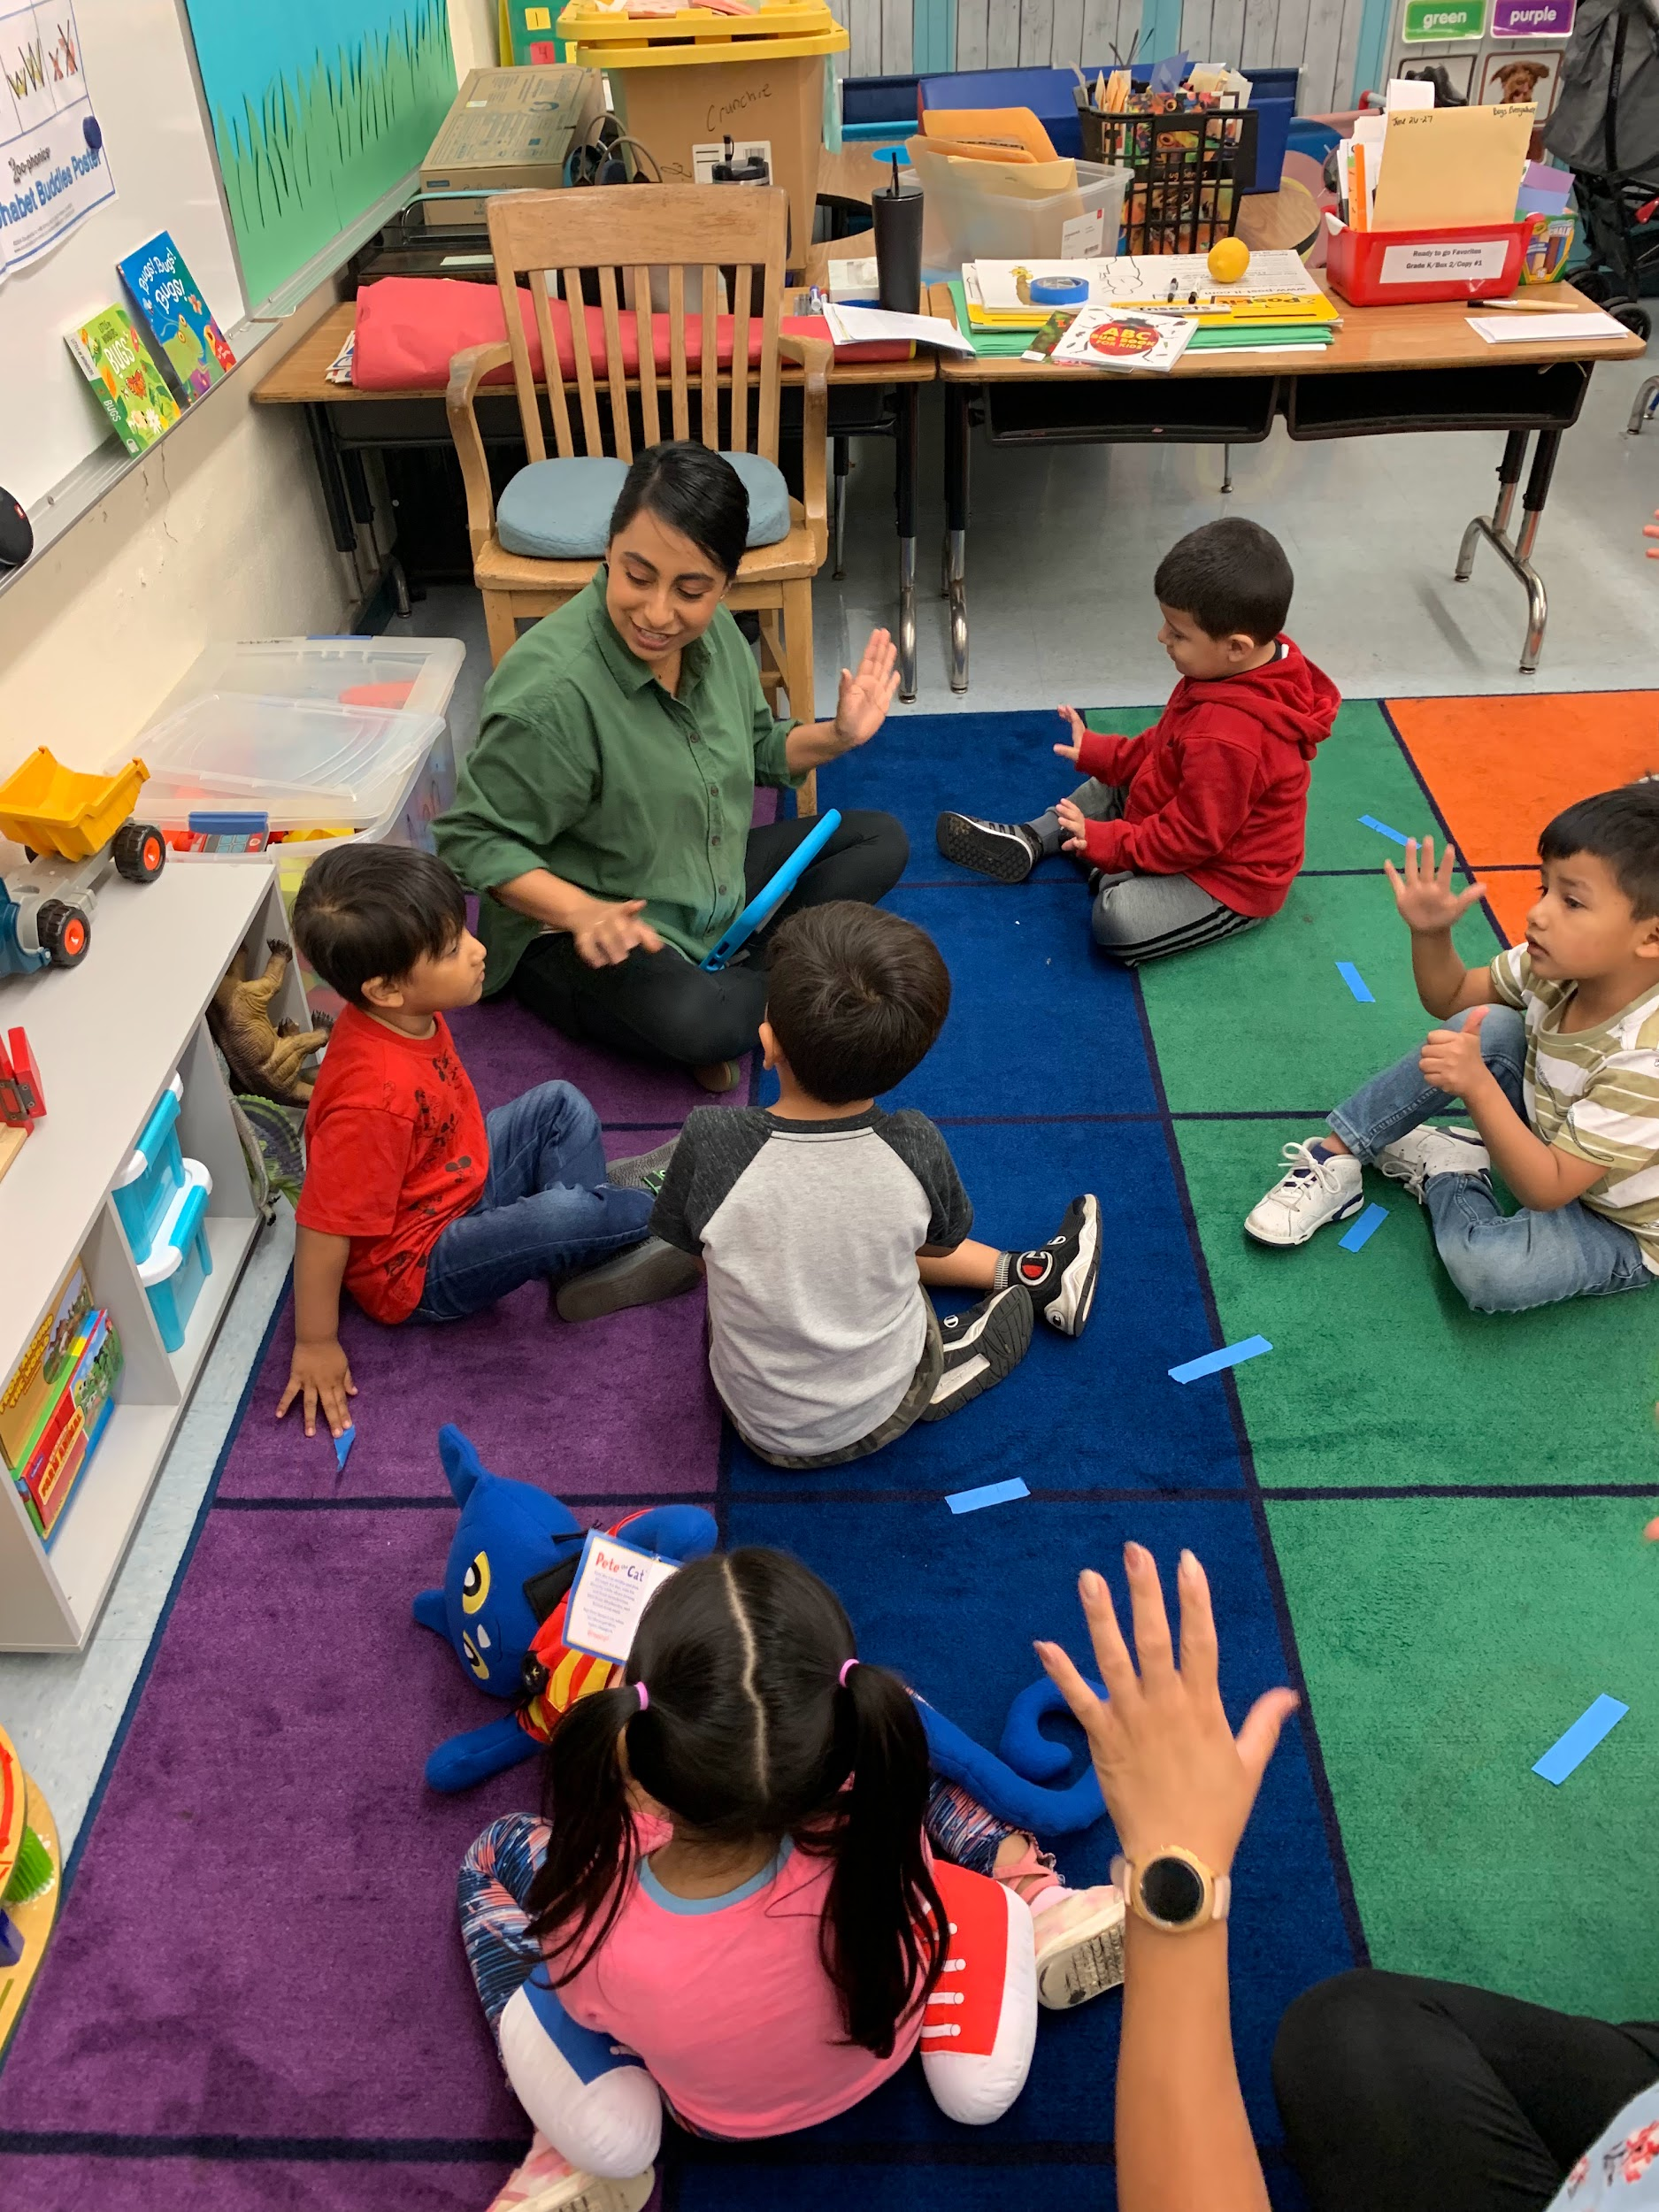
Parent Workshops with LACOE and others: The MEP Summer Parent Workshop Series seeks to build on our family’s strengths, cultures, and values to enhance parent-child communication, promote self-advocacy and self-care, develop English language skills, establish family reading routines and early literacy, and create culturally responsive narratives, poetry, and art. In addition, community partners offer workshops on first aid, immigration laws, and services for children and adults with special needs, and suicide prevention. The workshop series is an investment in mothers, increasing their capacity to raise happy, healthy families.

School Readiness
The Migrant Education School Readiness program prepares children ages 3-5 for success in school. The school readiness program also develops language skills in English as well as the student home language, if other than English.
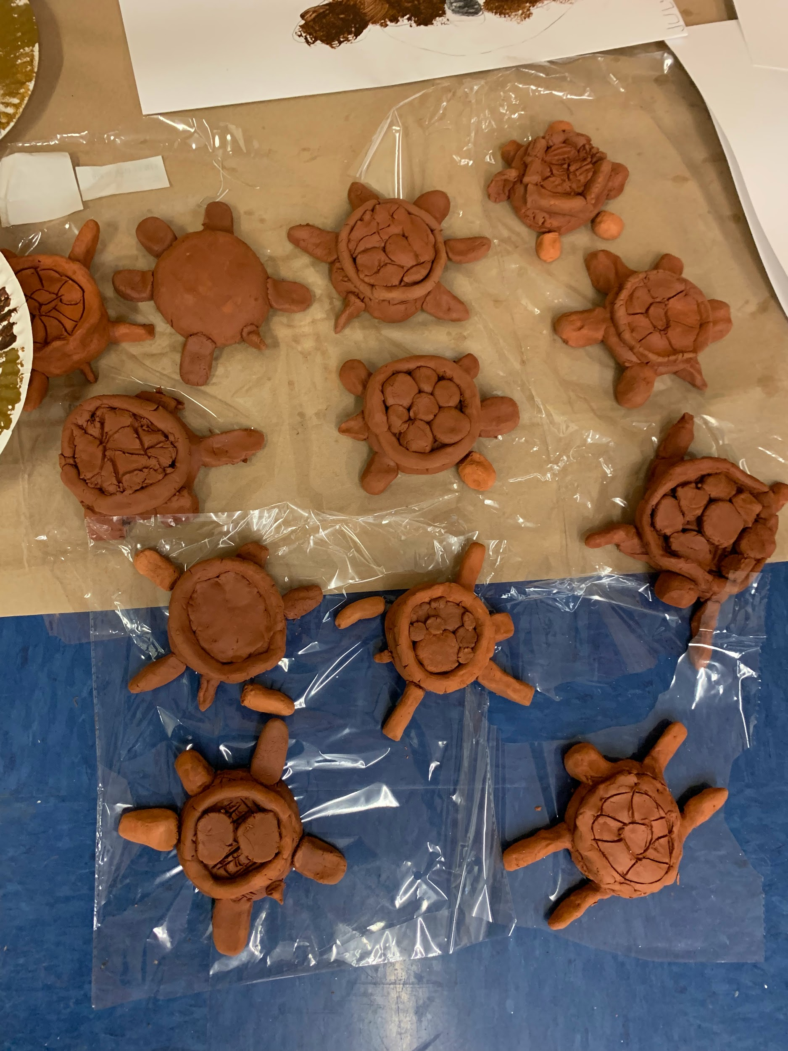
Summer Art
Visual arts are integrated into the student’s units of study for students in the Migrant Education Summer Program. For example, 3rd grade students are working with zoologist at the LA Zoo to study the California Desert Tortoise. Working with our art teacher, Laura Hernandez, students create clay models of the California Desert Tortoise.

Professional Learning Community
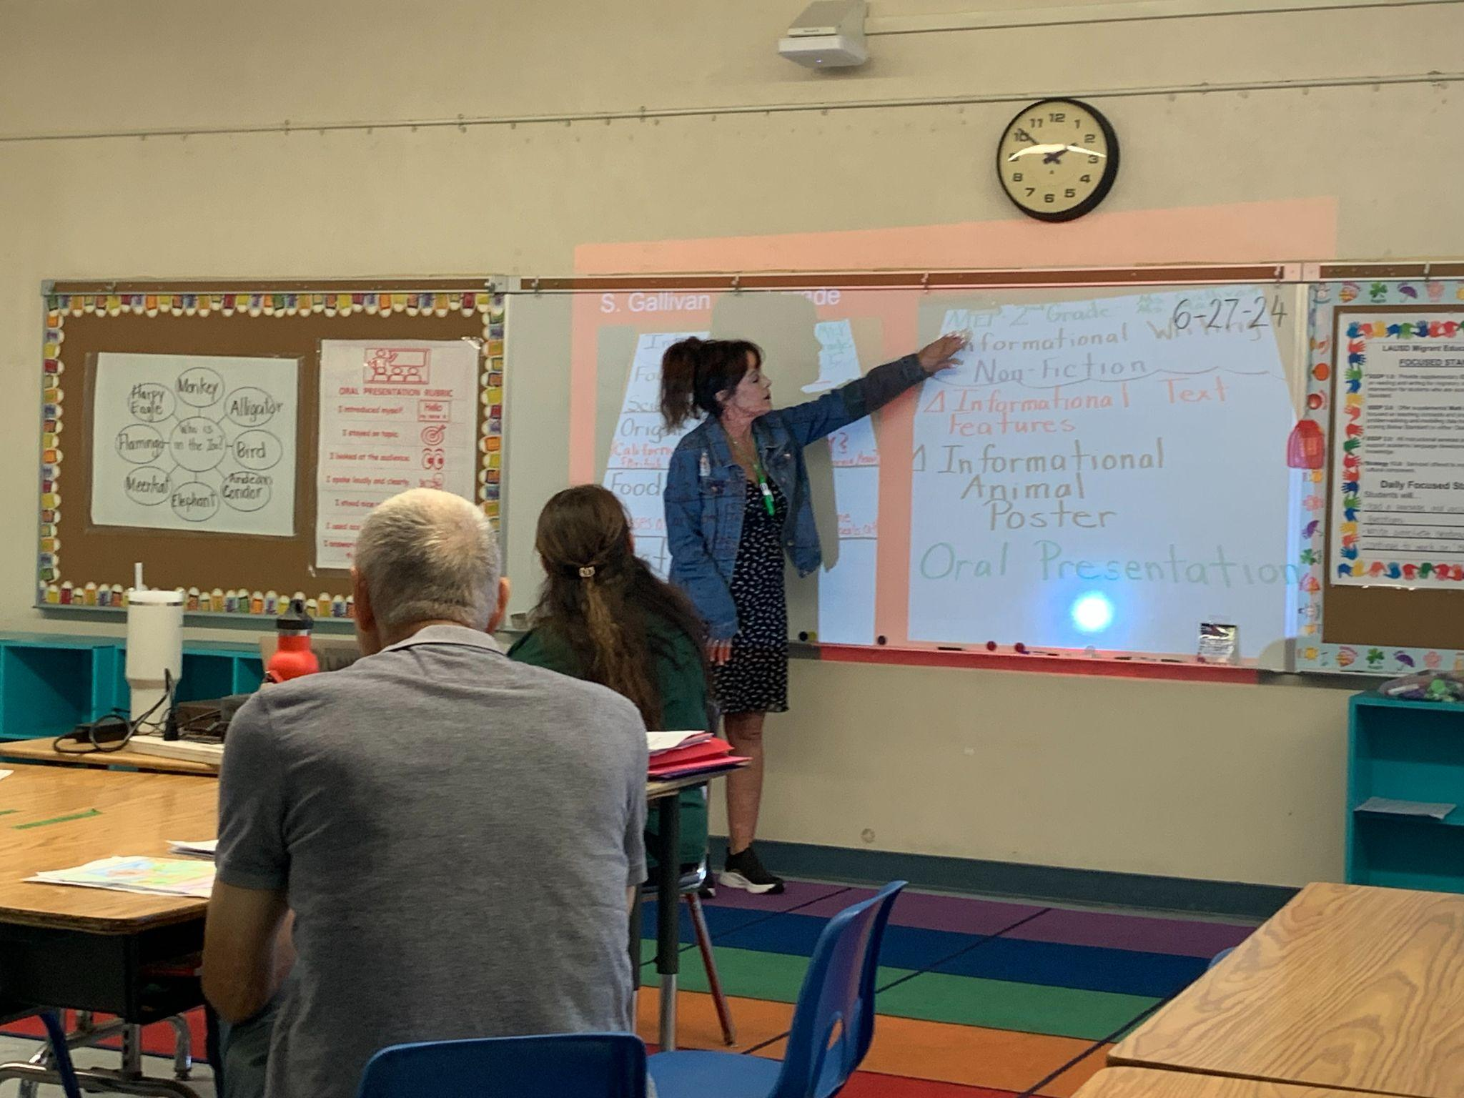
Migrant Education teachers collaborate in Professional Learning Communities to review student work and identify implications for improving student outcomes. Teachers cultivate mutual trust, fostering open discussions about students’ requirements. Following lesson planning, educators exchange insights by sharing student work samples. These samples serve as valuable tools for guiding the creation of subsequent lessons aimed at assisting students in achieving mastery of state mandated standards.

VIRTUAL ENRICHMENT

The Virtual Enrichment program for this year's Summer of Learning has made 90 courses available to students ranging from art, music, STEM, animation, cultural heritage, CTE exploratory, world language courses, and various credit-bearing courses. As of 6/28/24, 5,897 unique students participated in this week's virtual enrichment program. Students have expressed that virtual enrichment classes have been fun and engaging. We will share some highlights from a few virtual enrichment courses in next week's Summer School Program Newsletter.

To see a list of virtual enrichment course offerings, visit: enrichment.lausd.net

SUMMER TRANSITION SUPPORT HUBS
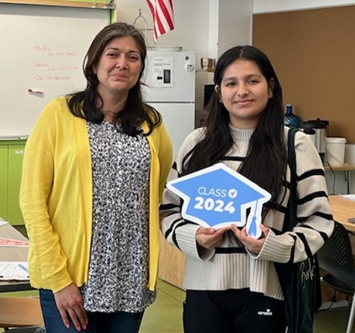
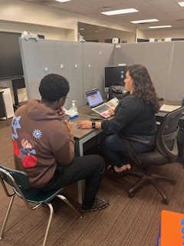
The Summer Transition Support Hubs are open for Class of ‘24 students in all regions.
Over 40 dedicated LAUSD counselors are on hand Tuesdays-Thursdays at the Hub sites and in a district-wide Zoom room to assist college-bound students with any questions regarding entering college in the fall. In the first two weeks, grads have received expert help resolving challenges with housing, registering for classes, meal plans, and financial aid. Many grads have needed intensive support getting official transcripts submitted to their chosen colleges to meet campus deadlines. Our amazing counselors are going the extra mile this summer to ensure every student can strongly transition to postsecondary education! Check out the student-facing flyer to share for more information.
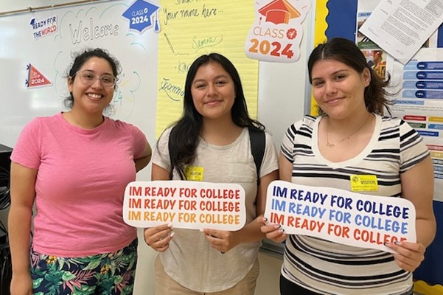
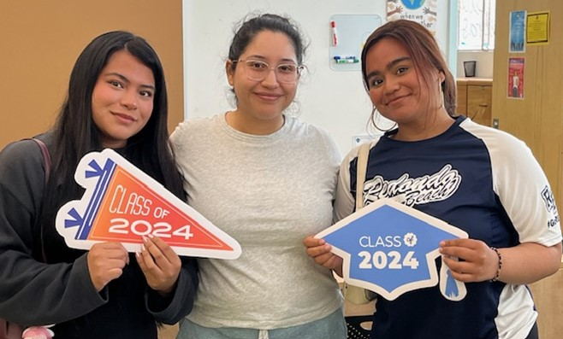
Thus far the Hubs have logged over:
- 7,400 emails & phone calls
- 110 in-person visits
- 160 virtual visits

CTE-LINKED LEARNING

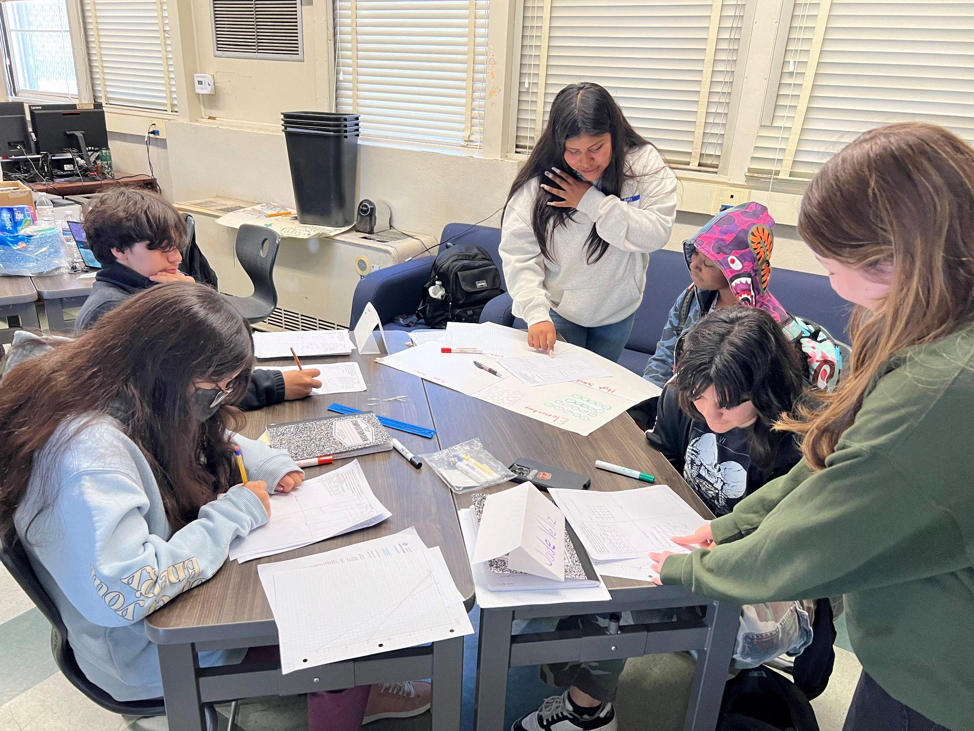
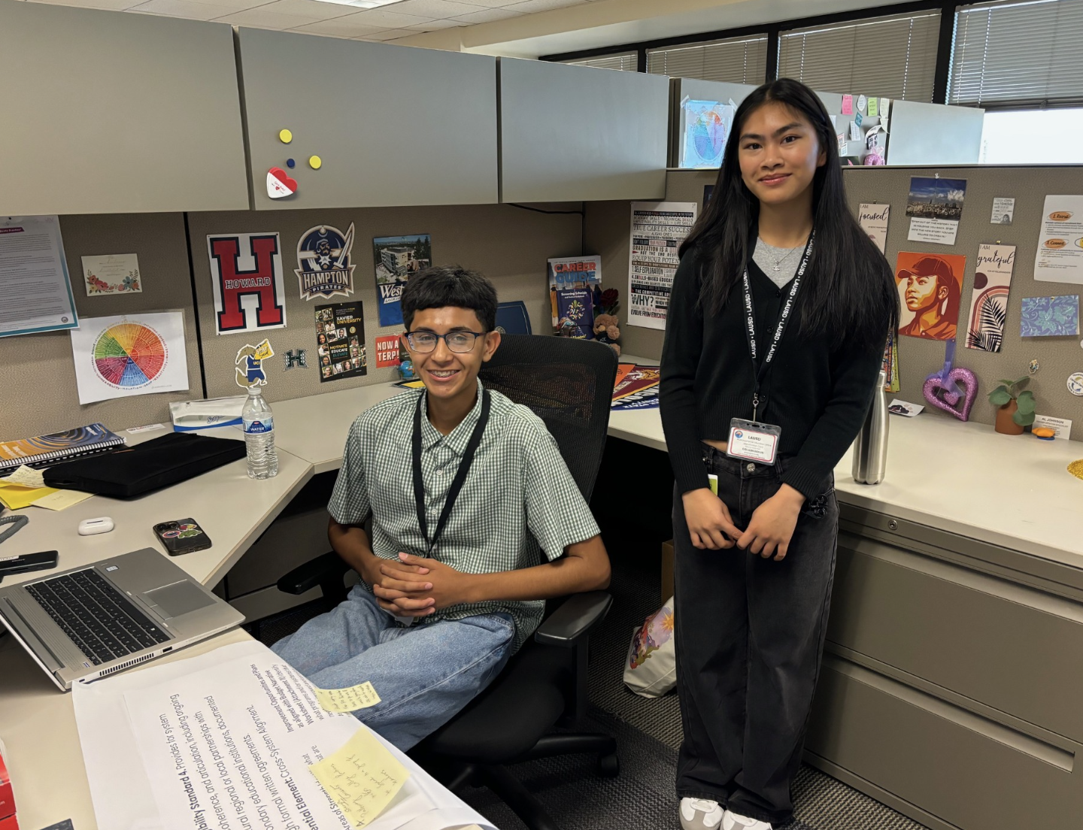
Summer Internships
This summer there are 338 students interning across the city of Los Angeles. Their placements include offices at Beaudry, regional offices, KLCS, Orthopedic Institute for Children, LA’s Best, Beyond the Bell sites and other partner sites (view the full list of worksites here).
For more information, please contact @esther.dabagyan@lausd.net.

CALIFORNIA STATE PRESCHOOL PROGRAM (CSPP) - ECED
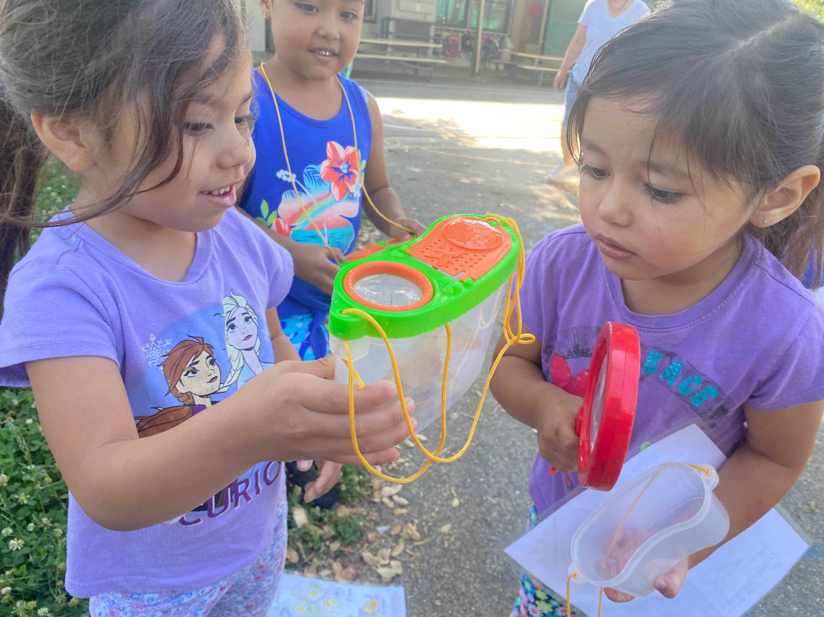
What’s all the buzz about in the California State Preschool Program (CSPP)? The Early Childhood Education Division is thrilled to welcome back our district’s sprightly sprouts for another round of summer fun and learning.
- 69* unique student enrollment for CSPP (as of 6/28/24)

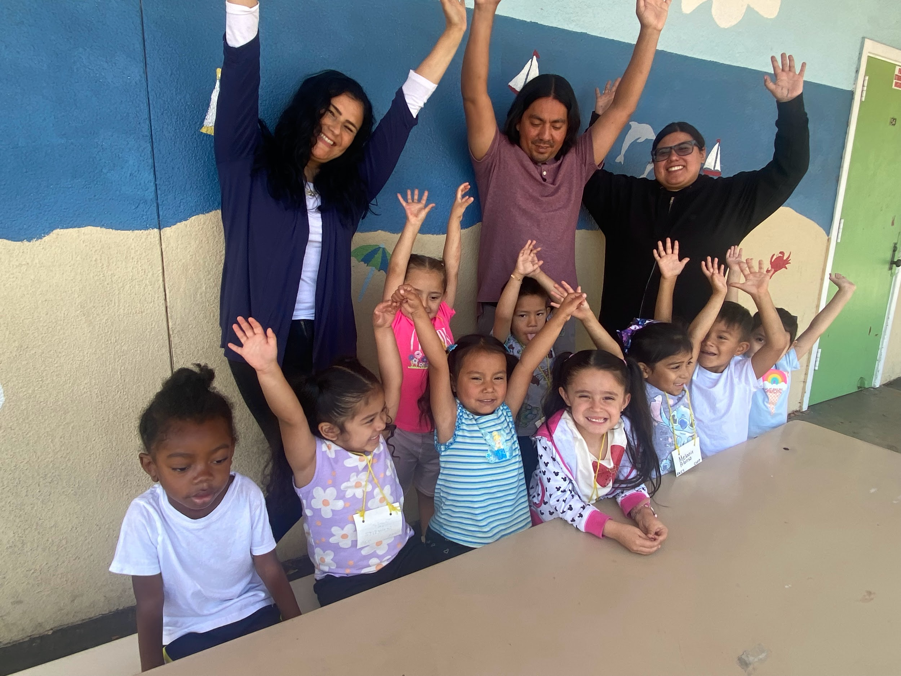
This summer, we’re diving into the fascinating world of insects, where our preschool learners will wiggle into the role of junior entomologists. CSPP Teachers and Early Education Center Aides have crafted an “ant-tastic” array of activities that are sure to captivate and educate. From butterfly metamorphosis to beetle biodiversity, our classrooms are “abuzz” with excitement and discovery!
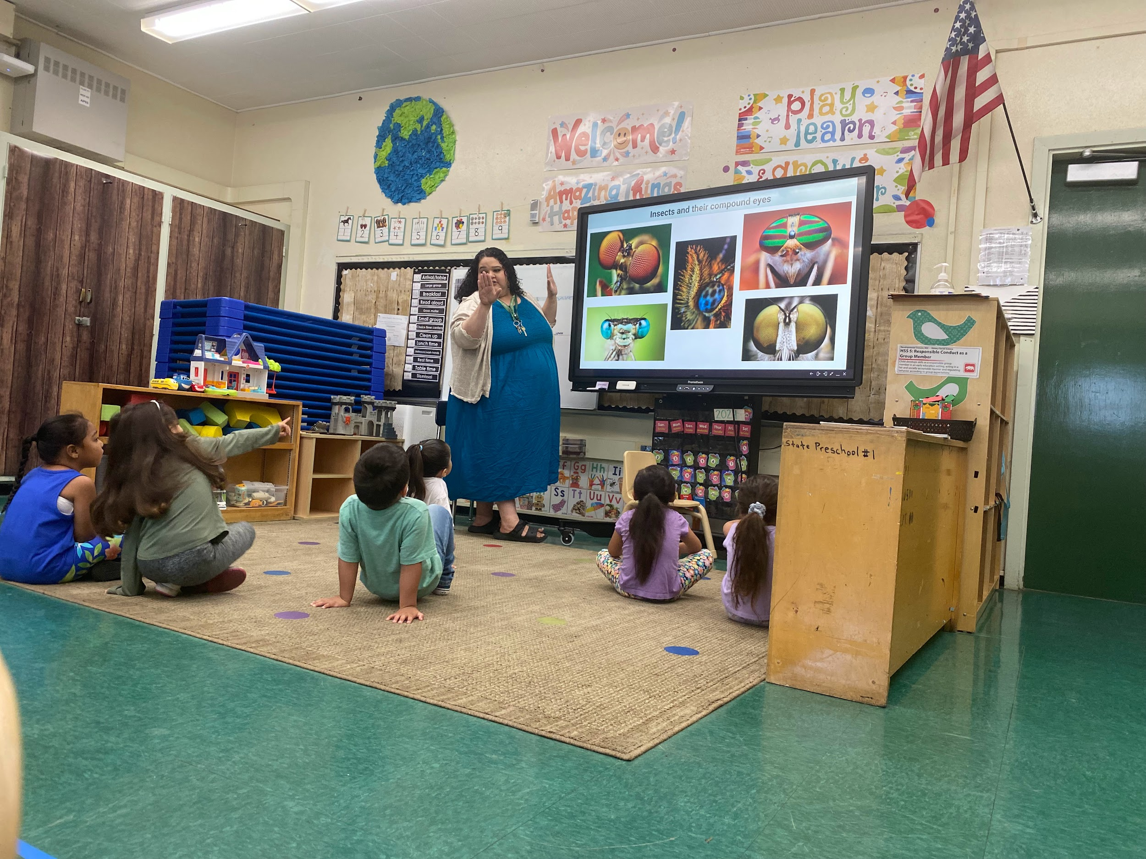
Pictured is Ms Maria CHAVEZ, with her students at Sheridan Elementary, where they had 100% attendance on June 26th! Also pictured are Preston MORENO, and Sidney OREA our wonderful Early Ed Center Aides!
For more information, please Raul MORENO at ECED. rmore13@lausd.net, (213) 241-0157

*Source: ODA Summer 2024 PowerBI Dashboard

